IGCSE Geography – Coasts & Beach Formation (Deposition)

Photo of a beach (one that I have been to)

Paste your beach photo into the space above. Then annotate the processes by which the beach has been formed using the information on geographypods and using the flow diagram below.

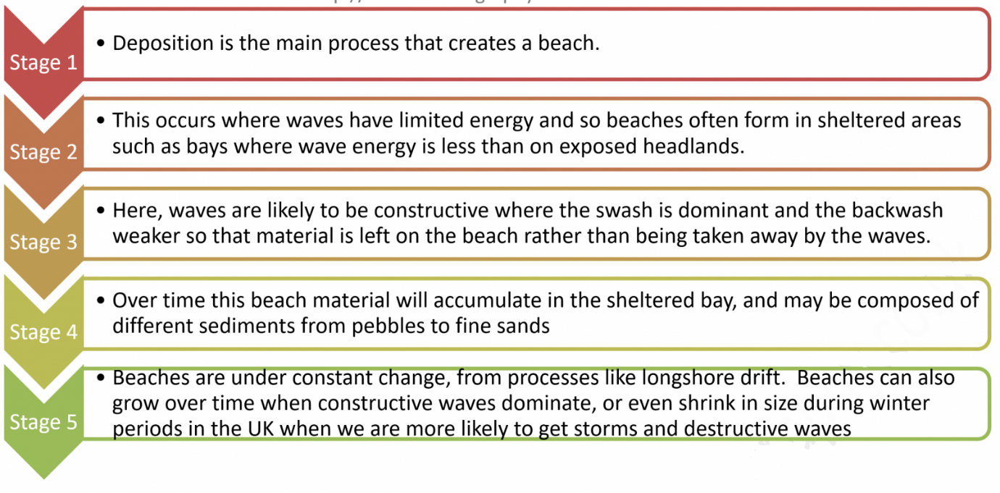
Source

Exam Practise – In paper 1, you may be asked a question such as the following: Explain, with the use of a diagram, how a beach is formed (5).

The flow diagram on the previous page tells you how a beach is formed and contains some important information on the types of waves necessary for beach formation and information on swash and backwash.

In the space below, spend 10 minutes drawing a neat sketch to show this process at work. Don’t forget to add labels to show key features of the beach (shallow, sediments) and the coastal processes (constructive waves, LSD, swash, backwash).

Remember:

Steeply sloping beaches are formed by strong __________ waves that ____________ more material away from the beach that they swash up the beach.

__________ sloping beaches occur by constructive waves that ______ more material up the beach than they backwash away, building up a steep beach ________.

Swash backwash gradient gently destructive

