IGCSE Geography Coasts – Bays & Headlands (erosional feature)
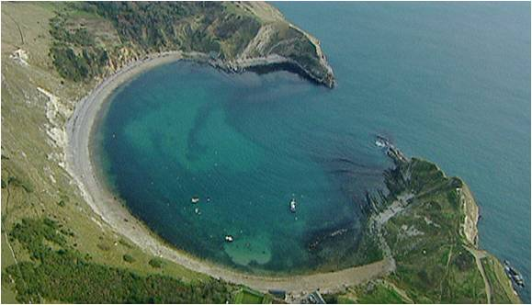
On the photo above, label the bay, the beach, and the two headlands.

What type of human activity might happen at a feature like this? Can you see any evidence of this on the photo?

After watching the video and studying the diagram on the website, draw an annotated sketch to show the formation of a bay and headland in the space below.

