IGCSE Geography – Tourism Case Study Bali

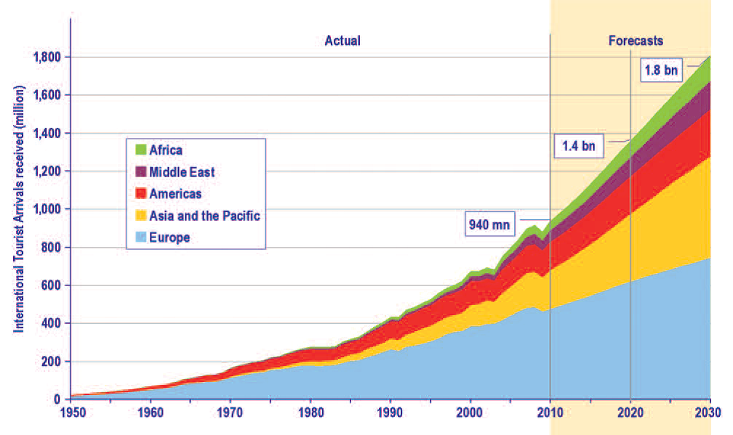

The graph above shows the increase in tourism from 1950 to 2030 (projected). Describe the trends in global tourism since 1950.

State the total number of tourists arrivals in millions to the following regions for 2020
Africa
Middle East
Americas
Asia and Pacific
Europe

There are two dips in tourism on the world tourism graph. One in 2001/2002 and one in 2007/2008. What could account for these dips in tourist numbers?

Introducing Bali
To carry out this piece of work, you will need to watch the Journeyman YouTube video embedded on geographypods.

Using the embedded map on geographypods, describe the site and situation of Bali.
Site (where it is physically located)

Situation (its position in relation to the surrounding human and physical features & what caused it to develop & grow)

Conduct some further research into Bali and make a note of the physical and human attractions of the island.

Journeyman – YouTube Video Activities

Watch the video embedded on Geographypods
Watch up to 06:30 to get the background information on Bali and the rise in tourism numbers since the 1970’s.
Make notes here of any interesting facts, dates or numbers.

How much has the total population and the total tourist numbers grown since the 1970’s in Bali?

What is the biggest problem associated with tourism in Bali?

What is the issue in the town of Kuta? Write about what the local people say too.

12:12 – What are the issues caused by the construction of large hotel projects?

15:50 – Outline what life is life in rural Bali in the village of Ubud.

What is happening to this rural land?

20:27 – What does the governor of Bali, Made Pastika, think of the tourism industry in Bali? What are the problems and benefits that he talks about?

Outline the tariffs that are imposed on locals and tourists in the main bars in Bali?

Press CTRL and click on the screenshot of the news item above (or click here) to read the full story. Outline the other negative effects of tourism linked to global terrorism. Who were the targets in the attacks?

Press CTRL and click the Bitesize link above or here to access the IGCSE revision materials on tourism. In the space underneath, outline the positive impacts of tourism on a destination such as Bali.

The effects of a growth in tourism are generally positive and that careful management is needed if problems are to be avoided. Choose one of the following two questions to answer:

IGCSE Exam Corner: For a named area, explain how tourism is damaging the natural environment (7)

For a named area, describe the socio-economic impacts of tourism on the destination (7)

