IB Geography – Global Interactions
Alternatives to Globalization – The Amish
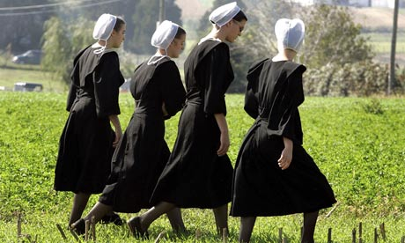
This case study focusses on the Amish. You will find some information in the table beneath on how the Amish still avoid the process of globalization in 2013 and other forms of it that they have found more difficult to prevent.

Sort out the statements into order. There are two titles:

i. Avoidance of Globalization | ii. Globalization of the Amish

Anti-individualist (avoidance of labour saving technology so that they can work as a community) | Expensive land prices and growing populations have forced many Amish to work outside communities | Many groups still where traditional dress (must be plain and simple), use traditional tools and traditional forms of transport
Amish have opened tourist shops selling handicrafts | They have largely separated themselves from society because they believe they are ‘Gods own people’. | Some groups have allowed the use of cars
Many speak traditional language ‘Pennsylvania German’. | Telephone discouraged to encourage direct communication | They do not used motorised farm equipment, but do use pesticides and fertilisers.
At the age of 16, members can spend time outside the community to decide if they want to remain a member, 90% decide to remain a member | Most Amish now also speak English | Amish do not use mains electricity (must be self-generated)
No computers, TVs or mobile phones
The Amish & Positive & Negative Quality of Life (QOL) Indicators.
Sort out the following statements into the relevant columns below

Positive QOL indicator | Negative QOL indicator

Lower than average rates of cancer because of their clean living e.g. simple diet and limited use of tobacco and alcohol. | High incidence of genetic disorders (small gene pool) | Suicide rates below national average (family support?)
Education stops at grade 8 | Close family ties and support network e.g. care for elderly | Above average infant mortality (compared to US)
Low rates of theft, fraud and other non-violent crimes | Overpopulation because of reluctance to use technology (food shortages) | Reluctance to use contraception has also led to overpopulation
Avoidance of medical care | Above average in lower grades (spelling, word use and mathematics) | Discrimination from outside because of lack of understanding
Little pollution because of no electricity | Physical abuse (corporal punishment) | Self-sufficient so are not vulnerable to changes in supply and demand of goods
High profile sexual abuse cases (often not reported) | Pacifists so all disputes will be resolved within the community | Healthier diet, because people don’t east fast food, but a more basic healthier diet.
They don’t accept state benefits during hard times | Women are subordinate to men (also true in many societies) | Maintain traditional culture

