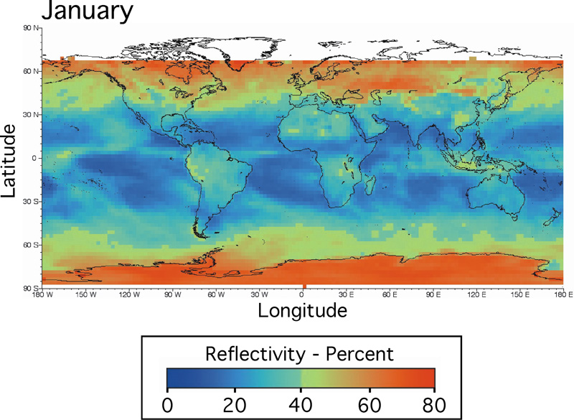
With reference to the map, describe and explain the global variations in Albedo. (5)

