IGCSE Geography – Africa & Future Population Growth
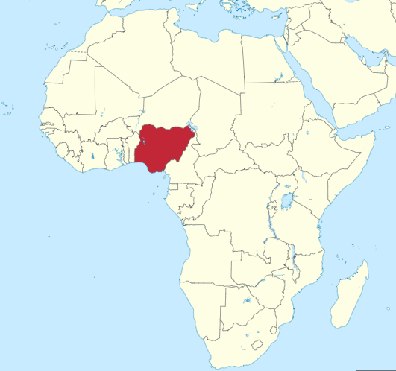
Research Task 1 – Using the map, describe the position of Nigeria within the continent of Africa.

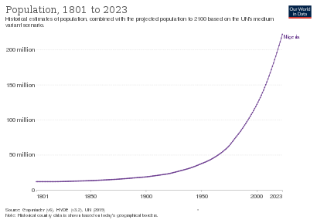

Research Task 2 – Using the population growth chart above, describe the population trend in Nigeria between the year 1800 and 2023.

Research Task 3 – Now read the ‘Population’ section of this Wikipedia article and explain why the population in Nigeria has increased so rapidly.

Now listen to the BBC Podcast – How will a population boom change Africa?

“In just 35 years the population of Nigeria has doubled. The growth will be huge, quick, and inevitable!

Part 1 – ‘The numbers’ 50-word summary (1 minute 20)

Part 2 – ‘Traffic Jam in Abuja’ 100-word summary. (Focus on Nigeria)
Causes of fast rapid population growth in Nigeria | Impacts of rapid population growth in Nigeria

Part 3 – ‘Get Rich Quick’ 50-word summary

Part 4 – ‘Live Long & Prosper’ 50-word summary

Once the Podcast has finished, please go here and watch this short VOX video about another problem that Nigeria is facing. Make some notes in the space below about Boko Haram.

