IGCSE Geography – Africa & Future Population Growth – BBC Podcast
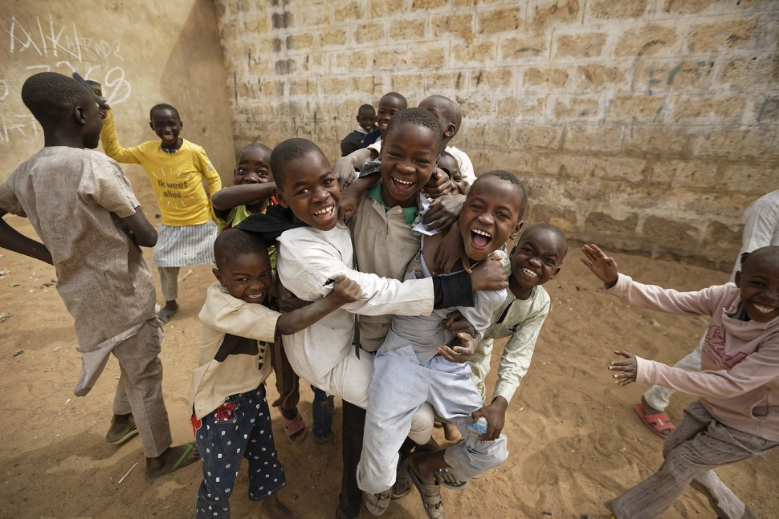
Part 1 – 50-word summary | Part 2 – 50-word summary
Part 3 – 50-word summary | Part 4 – 50-word summary

