iGCSE Geography – Google Street View Evidence - Zones of Toulouse
Zone | Google Street View | Description of evidence  http://www.bbc.co.uk/schools/gcsebitesize/geography/urban_environments/urban_models_medcs_rev2.shtml
CBD
Factories Industry
Industrial Wedge
Low Class Residential | 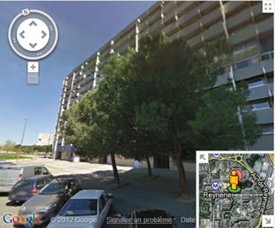
Medium/High Class Residential

