Year 7 Nosy Geographers
Who ?
Photo Caption – What’s Going On?

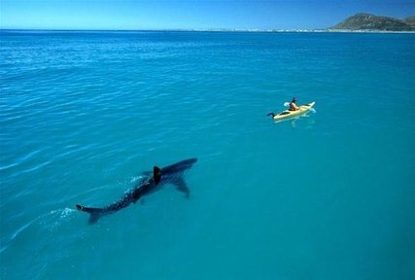
Why ?
What ?

Where ?
When ?

