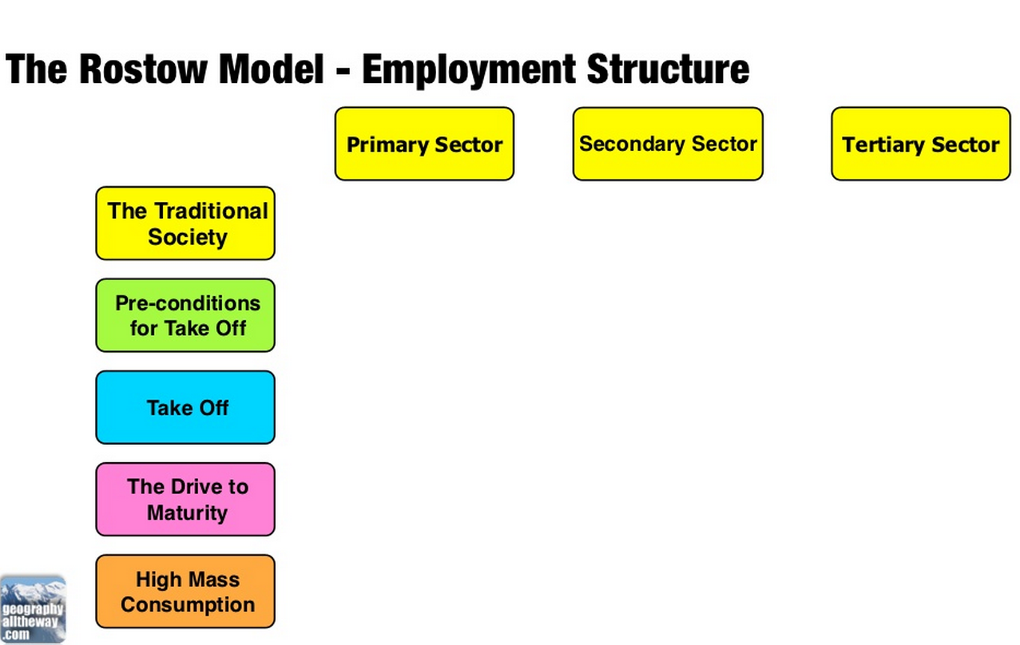
IGCSE Geography – Changing Employment Structures.

