Mozambique & Rapid Population Growth
Don’t Panic – BBC2 Documentary

- Watch the sequence of the video where you are introduced to Olivia & Andreas and their family in rural Mozambique. Annotate around the photo below the social, economic and environmental issues that affect their lives.

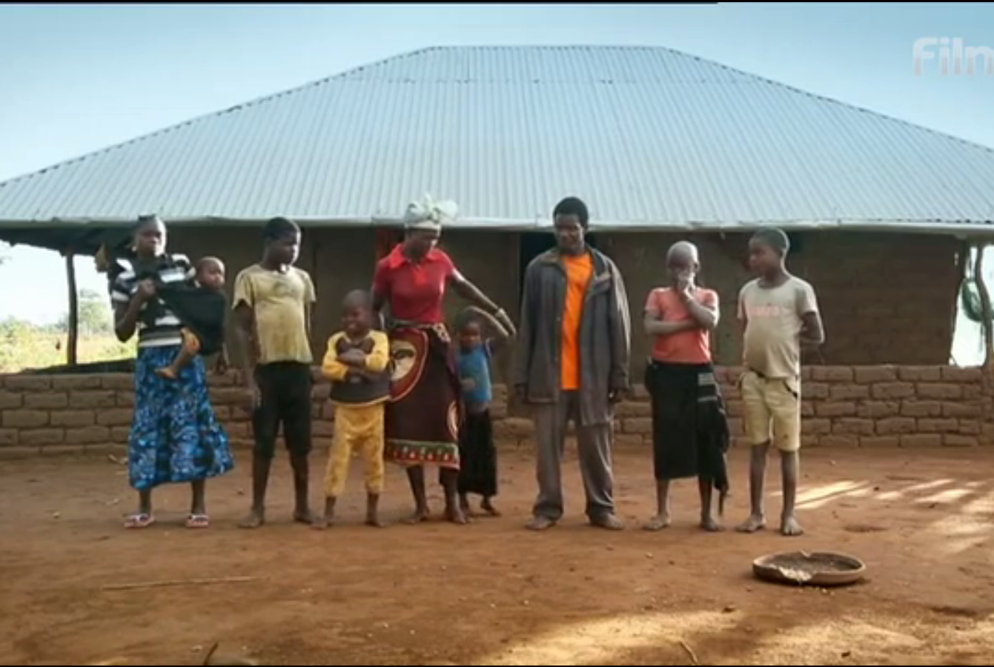

- Outline the main reasons why Olivia & Andreas have a large family even though they are barely able to provide for them all.

How can bicycles boost development in Mozambique?

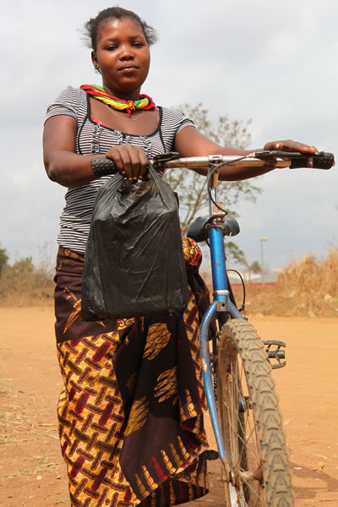

- Annotate around the image above the economic and social benefits of a bike for a typical family in Mozambique.

- Outline how the new bike will help Olivia and Andreas to progress socially and economically (pedaling their way out of extreme poverty)

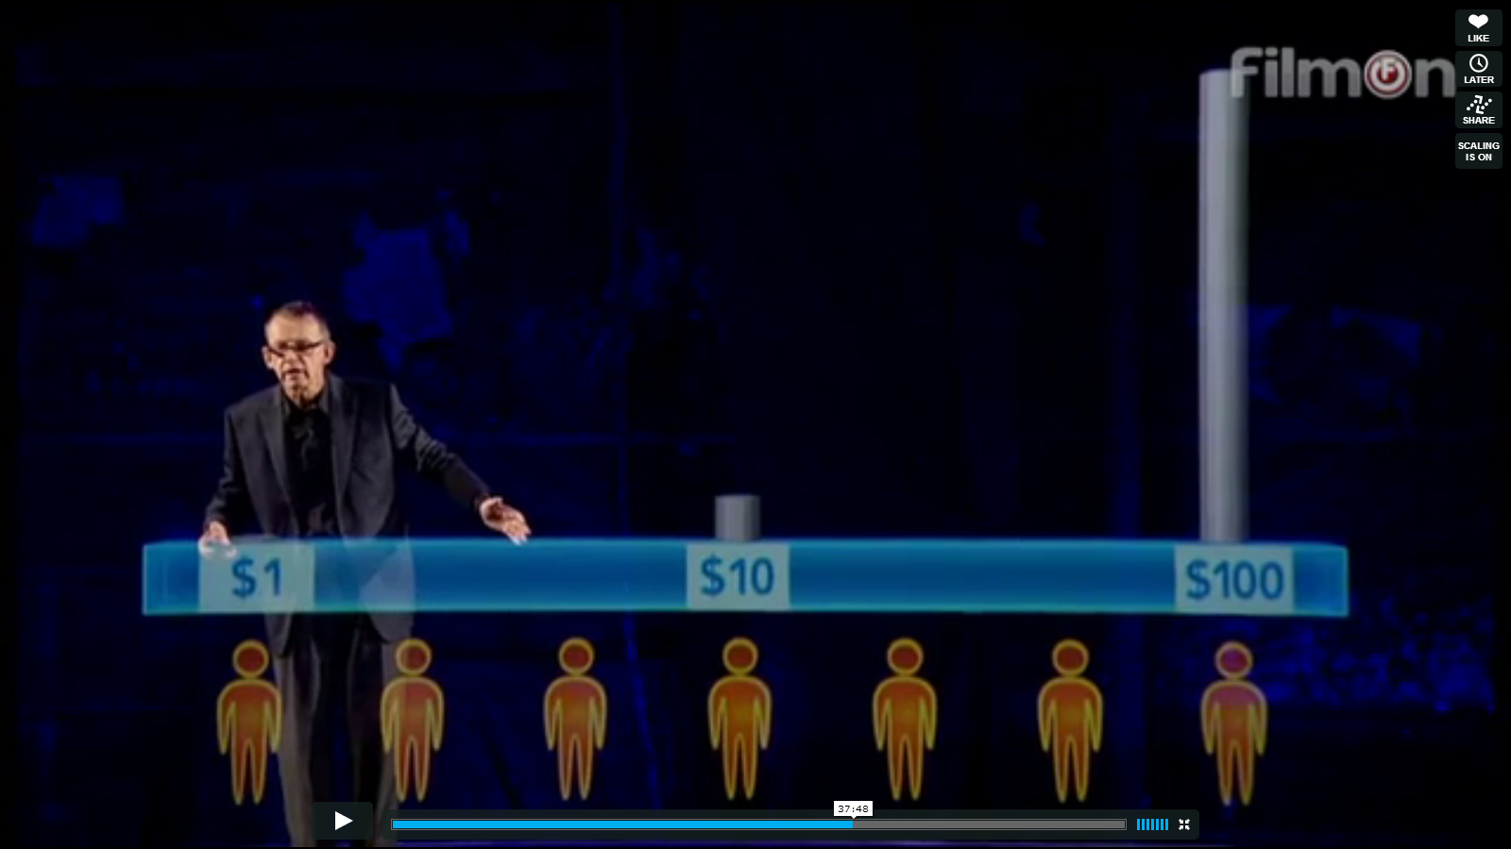
Add a suitable title to this image here:
- Watch the sequence on wealth distribution on the documentary. On the image above, add a title and then the line that represents extreme poverty. What is the value to be considered to be extreme poverty? ____________

- Outline how income per day is linked to investments in transportation.

- What issues does looking at poverty from a ‘developed’ or ‘rich’ point of view pose to those at the bottom end of the scale?

