**iGCSE Geography @ IST – Drought Case Study Name ________________________**

Outline the physical causes of the drought in the Sahel region. (4)

a. Describe the physical processes leading to the occurrence of a drought (3)

b. Human activities can make the effects of drought worse. Explain how this happens (6)

Watch the 1st video below, and then complete the questions in the response box – right.

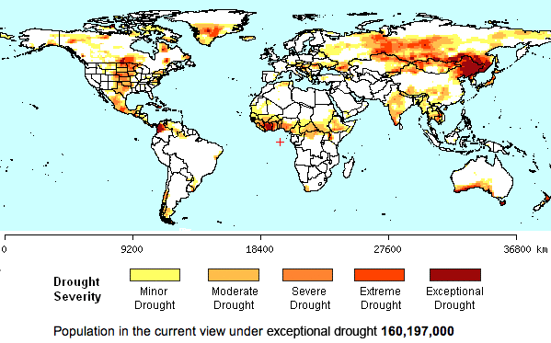****



Describe the distribution of severe to exceptional drought events. (2)

How does a high fertility rate (7 children) contribute to the problems caused by drought in this part of Africa? (3)

Watch the 2nd video then complete the S E E Effects of the drought in the Sahel

1. Social ([this graphic](http://www.unicefusa.org/assets/highslide/images/large/SahelGraphic-800.jpg) might help)
2. Economic
3. Environmental

(6)

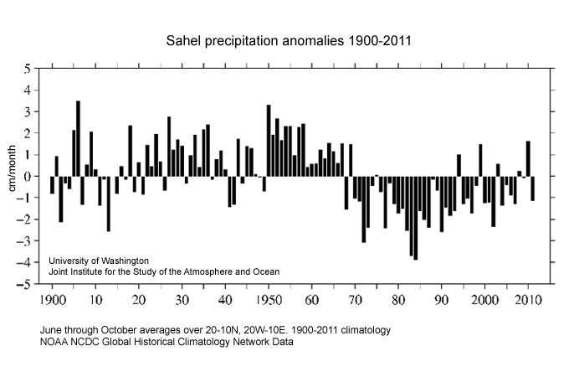

Study the Sahel precipitation anomalies graph to the left. Comment on the trend of precipitation since the 1950’s. (3)

How does this link to the drought in the Sahel region? (3)

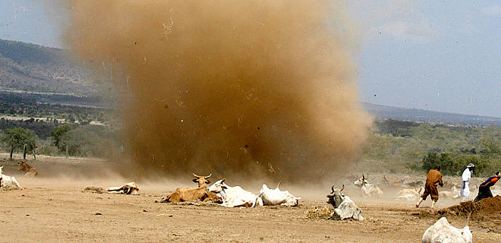

How can the risk of drought be minimised in the Sahel? Last video 6:45 onwards. (6)

Total Score /35