Population Growth & The Environment
Don’t Panic – BBC2 Documentary
- Watch the sequence on fossil fuel usage compared to population wealth where you will see graphics like below.
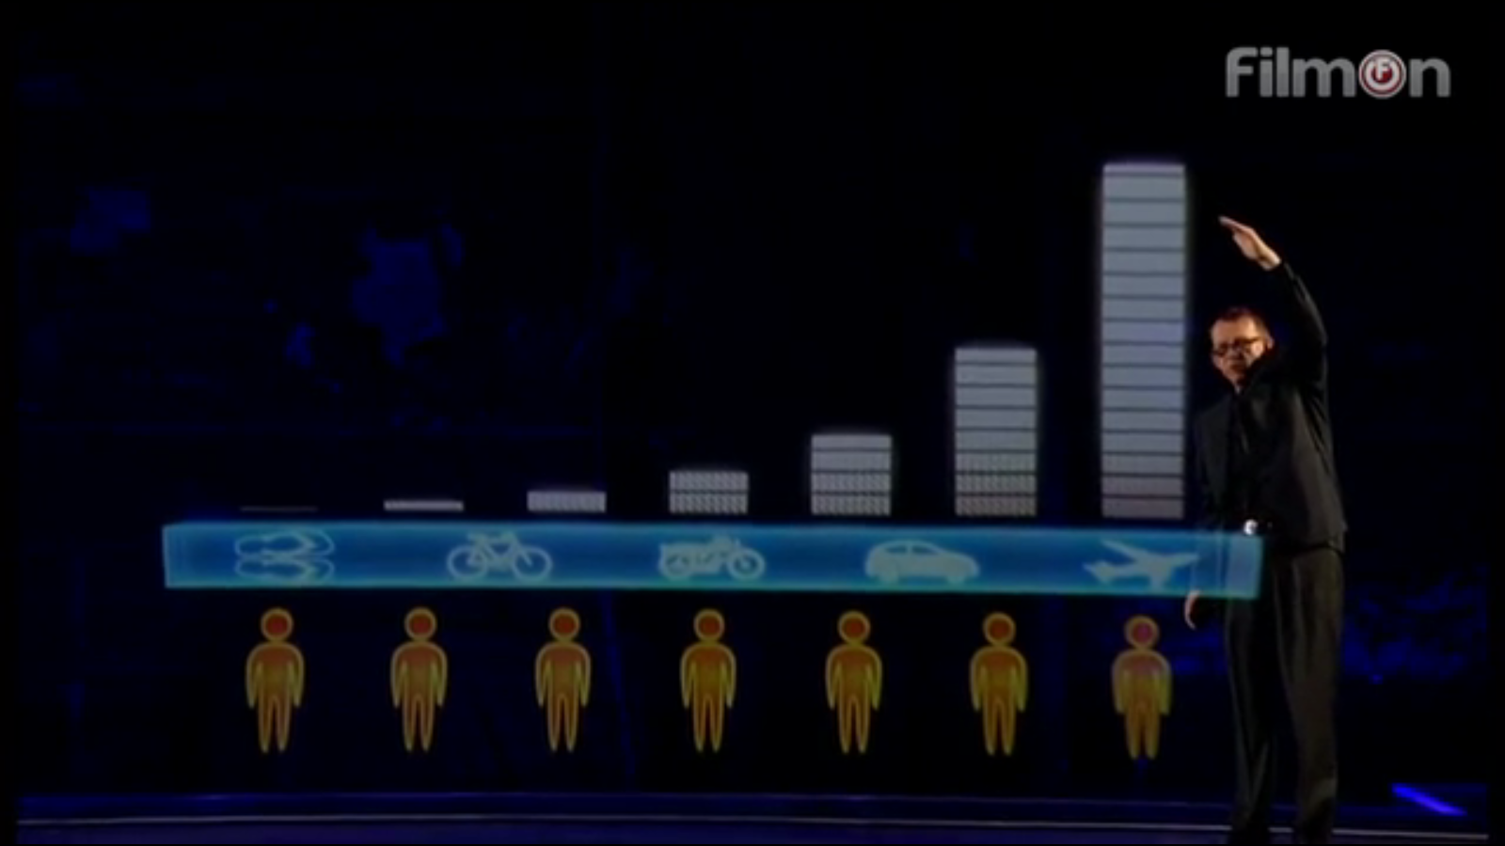
View from so-called MEDC’s - “Those over there you cannot live like us. You will destroy the planet”
View from so-called LEDC’s – “Who are you to tell us that we can’t live like you? You better change first if you want us to do it differently”.
- Study the quotes from Hans Rosling taken from the video. Explain the relationship between wealth, fossil fuel use and taking the lead on environmental sustainability.
Ensure you refer to future population growth areas and methods of transportation.

