Stage 1
Case Study: Traditional rainforest tribes

- The only populations still in Stage 1 are traditional rainforest tribes.

- Such tribes live in Indonesia, Brazil and Ecuador.

- The tribes are only small and have no contact with the outside world.

- Birth rates and death rates remain high.
High fluctuating

Birth rate High
Death Rate High
Population Low and fluctuating

- Little health care, low life expectancy and no birth control.
- Population fluctuates due to disease, famine and war.

France’s population was in Stage 1 before the Industrial Revolution.

Stage 2
Case Study: Afghanistan

- Afghanistan is one of a very small number of countries in Stage 2.
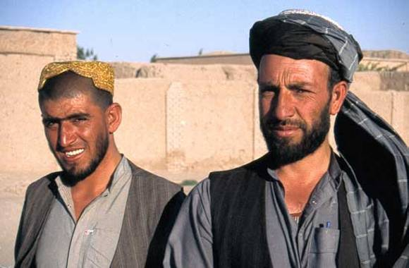
- The country is extremely poor due to war and instability.

- It has one of the world’s highest birth rates at 46.2.

- The death rate of 20 is much lower, leading to a 2.6% annual increase in population
Early expanding

Birth rate High
Death Rate Rapidly decreasing
Population Rapidly increasing

- Improved standards of living, hygiene and access to health care reduce down the death rate.
- Life expectancy increases.
- The gap between birth rate and death rate leads to a high natural increase in total population.

The population of France was in Stage 2 during the early Industrial Revolution (1760-1880).

Stage 3
Case Study: Brazil

- Most LEDCs are currently in Stage 3 – Brazil is a Newly Industrialised Country (NIC) and becoming richer very quickly, but still has a Stage 3 population.
- Being a Roman Catholic country the birth rate is still high, but is rapidly falling due to improved living standards leading people to see the benefits of having smaller families.
Late expanding

Birth rate Rapidly decreasing
Death Rate Slowly decreasing
Population Slowly increasing

- The death rate continues to fall, albeit slowly.
- The birth rate falls quickly as birth control becomes available.
- It also becomes beneficial to have smaller families as children become more expensive (i.e. they go to school rather than working) – this also leads the birth rate to fall.
- France was in Stage 3 from around 1880 to 1940.

Stage 4
Case Study: USA

- The richest country in the world with the 3rd largest population.
- Much of the USA’s population growth today is due to immigration.
- Most immigrants are from Catholic Central America and are likely to have high birth rates, but Asian immigrants are also entering the US in large numbers and tend to have lower birth rates.
Low fluctuating

Birth rate Low
Death Rate Low
Population High and fluctuating

- Low birth and death rates will fluctuate with economic situation (i.e. people have more children when jobs are plentiful and wages are high).
- France entered Stage 4 after WW2. The birth rate increased in the 1960s when the economy ‘boomed’ and went down in the 1970s during a recession. Maybe this will happen again?

Stage 5
Case Study: Germany

- Germany is a highly developed country.
- Women becoming high-achievers in their careers and an ageing population have caused the birth rate to fall below the death rate.
- The government has to deal with more elderly people and an ever declining workforce to pay taxes.
Natural decrease

Birth rate Slowly decreasing
Death Rate Increasing slowly
Population Slowly decreasing

- Death rates increase as the proportion of older people goes up due to longer life expectancies.
- Birth rates also fall as people choose careers over family, or as economic uncertainty puts people off having children.
- Different countries have different reasons for being in Stage 5.
- Countries in Stage 5 include Japan, Italy and Germany.

