Desert Formation & Location
iGCSE Geography
Task 1 – Watch the 2:46 video on geographypods (David Attenborough) and annotate the Google Earth image below with information that explains why deserts form and their typical characteristics.

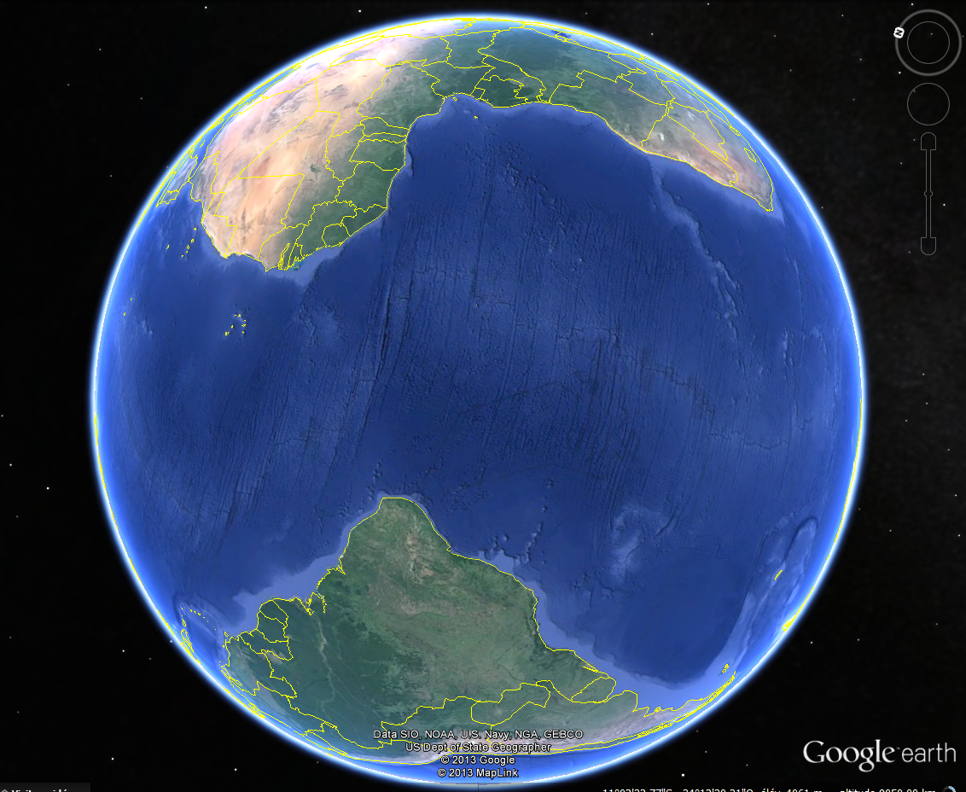

Locating Global Deserts: Using a suitable colour and reference, mark on the location and name the major global deserts.
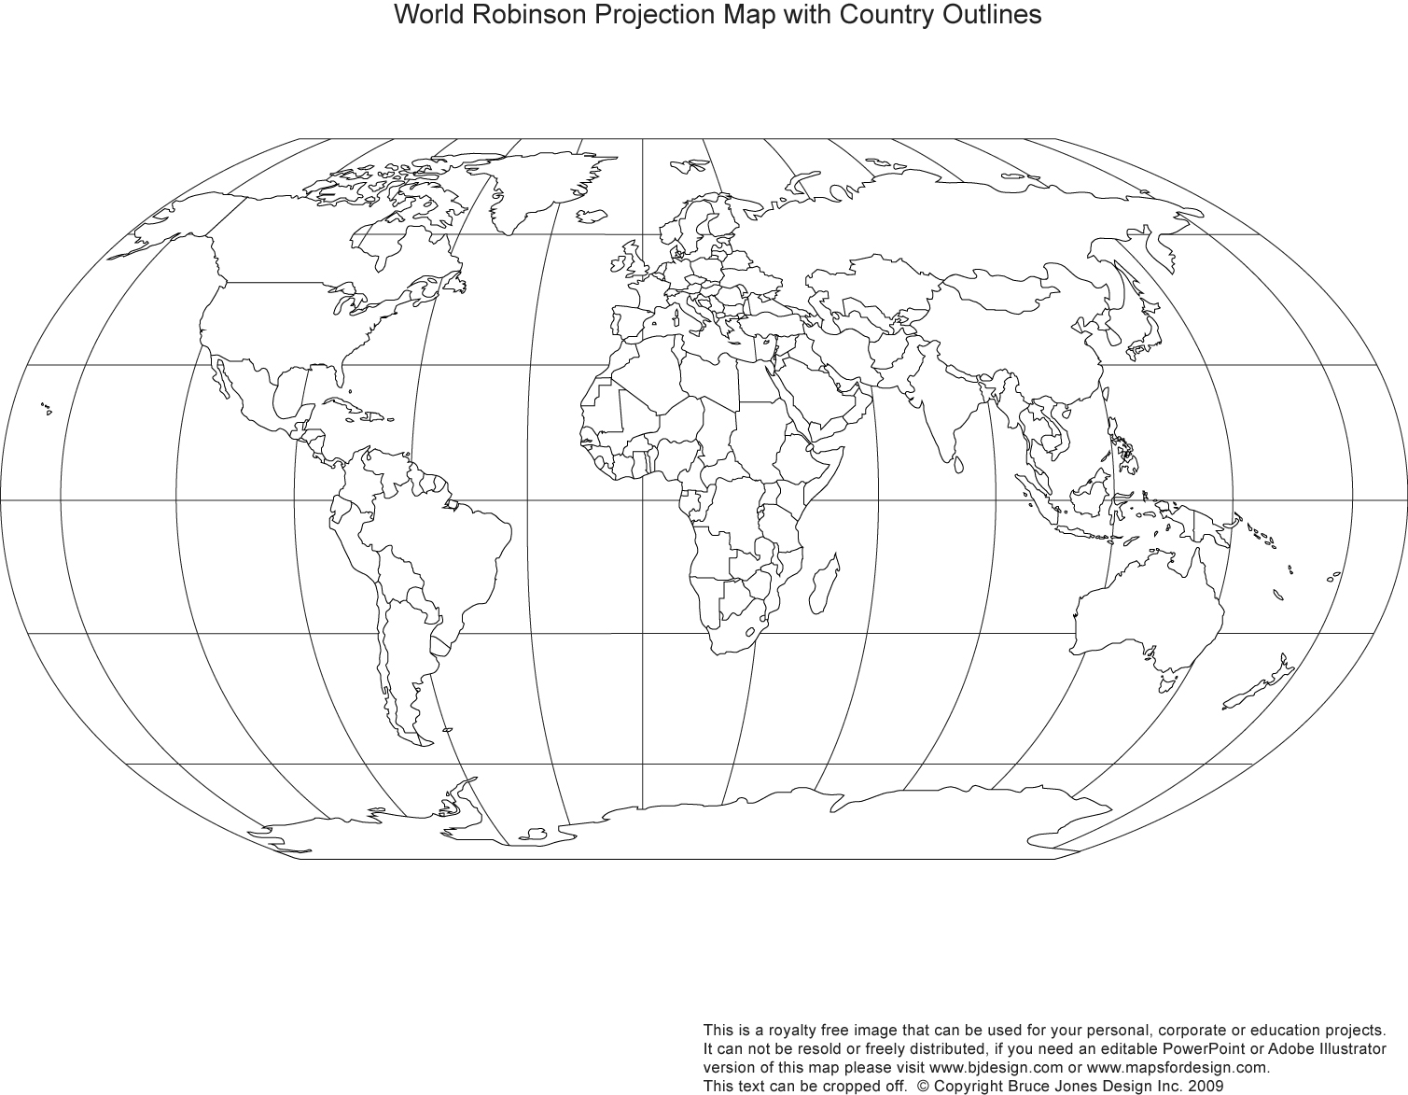

Describe the spatial distribution of deserts around the world.

