**iGCSE Geography – NIC Urban Models**

Zone Screen Shot

Zone Screen Shot

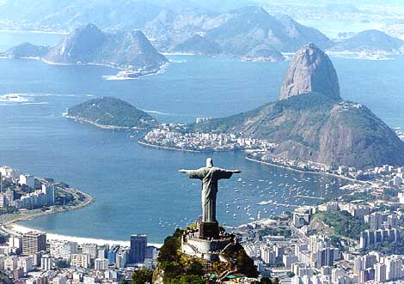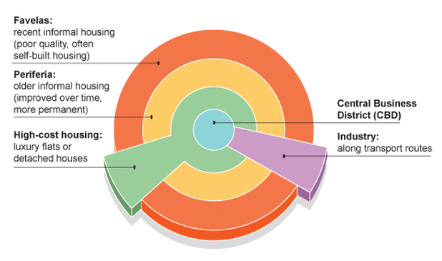

Zone Screen Shot

Sights, sounds and smells

Sights, sounds and smells

Zone Screen Shot

Sights, sounds and smells

Sights, sounds and smells