IGCSE Industry

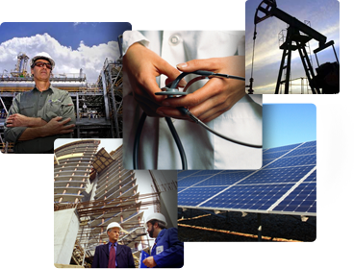

Name: ______________________________
Class: _______________
Job Classification

Most people do plenty of unpaid work around the home but before leaving school many of you will have a part-time job of one sort or another. Full-time work is very different!

People have always needed work to survive; we all need food, clothing and shelter. The earth provides these things, some of our food is caught by hunters or fishermen and most of our food is produced by farmers.

There are many different types of industry and these can be categorised into four groups:

Primary | Secondary | Tertiary | Quaternary
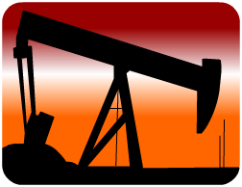 | 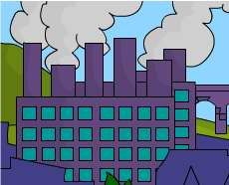 | 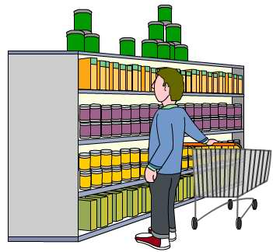 | 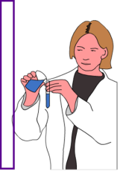
Primary Sector: The exploitation of raw materials from the land, sea or air e.g. farming and mining. | Secondary Sector: The manufacturing of primary materials into finished products e.g. car building, food processing or construction. | Tertiary Sector: The providing of services to individuals and other businesses e.g. teaching, banking, retail and nursing. | Quaternary Sector: The generation and sharing of hi-tech knowledge e.g. medical research, Google glasses development or web page design.

When you finish school, college or university, what do you hope to do?

Name of job:

Which sector:

Add a sentence to the table below that explains which sector each industry is located in.

 | Primary | Secondary | Tertiary
Car Manufacturing
Retailing
Coal-Mining
Iron And Steel Industry
Teaching
Farming
Fishing
Dentistry

- Explain why quaternary industry is a relatively new addition to the employment structures hierarchy.

How Do Global Employment
Patterns Vary?

The balance of jobs between the three categories in a particular area or county is called the employment structure. Use the table to complete the series graph below:

 | Primary % | Secondary % | Tertiary %
Bangladesh | 63 | 11 | 26
Brazil | 23 | 24 | 53
Cameroon | 71 | 12 | 17
France | 4 | 24 | 72
India | 60 | 12 | 28
Italy | 5 | 32 | 63
Japan | 5 | 25 | 70
UK | 1 | 25 | 74
USA | 2 | 24 | 74

Most goods or products are made in factories which can be categorized in one of two ways:

Heavy Industry – This is making large product such as ships, lorries and cars | Light Industry – This is making small products such as clothes and household goods
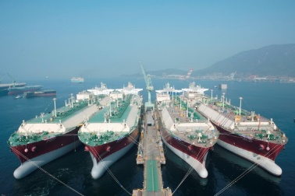 | 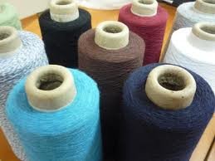

These are both secondary activities as products are manufactured from raw materials. In the past factories were built near to the primary industries and raw materials. People moved to these areas to live and work. This causes manufacturing towns to grow around local industry.
Today most people live on the edge of towns and cities and industry tends to follow. Factories employ local people and are near relative markets or trade routes.

Match the keywords to their definitions:

Heavy Industry |  | Goods to be sold
Light Industry |  | Natural materials from the earth or sea
Manufacture |  | To make goods
Products |  | When small goods are made
Raw Materials |  | When raw materials are made into goods
Secondary Activity |  | To find a place for a factory or business
Factory |  | Where large goods are made
There are a lot of factors which need to be taken into consideration when deciding where to locate a factory; these factors are grouped as physical or human and economic.

Highlight the words below to show whether they are physical or human or economic:

 | Physical | Human And Economic
Raw Materials
Labour
Transport
Power
Markets
Leisure Facilities
Site
Natural Routes
Government Policies

How Has Industry Changed?

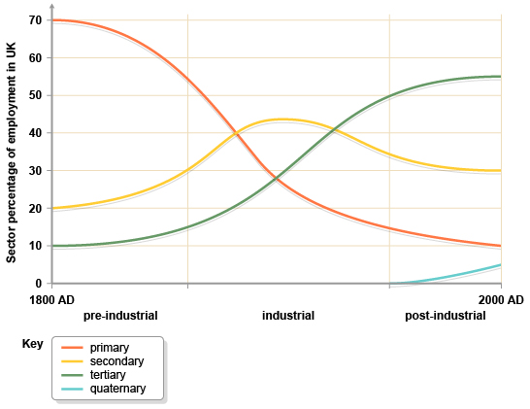
By 1800 _____% of people were working in primary jobs. They would have mostly been _______________.

At this time 20% of people worked in the _______________ industry. This would have included _______________.

The least worked in industry worked in in 1800 was the _______________ industry with _____%.

The industry which grew the most during the pre-industrial era was _______________ by _____% increase

Describe what happened during the industrial era:

Which type of industry appeared in the post-industrial era? How much as it grown? Why do you think this is?
_______________ industry, _____%,

Which industry has had the greatest downturn?
_______________ industry

This means there are less people working on farms in the EU, so where do we get our food from?

What do you think will happen to each type of industry in the future? Why do you think this?

Primary –

Secondary –

Tertiary –

Quaternary -

