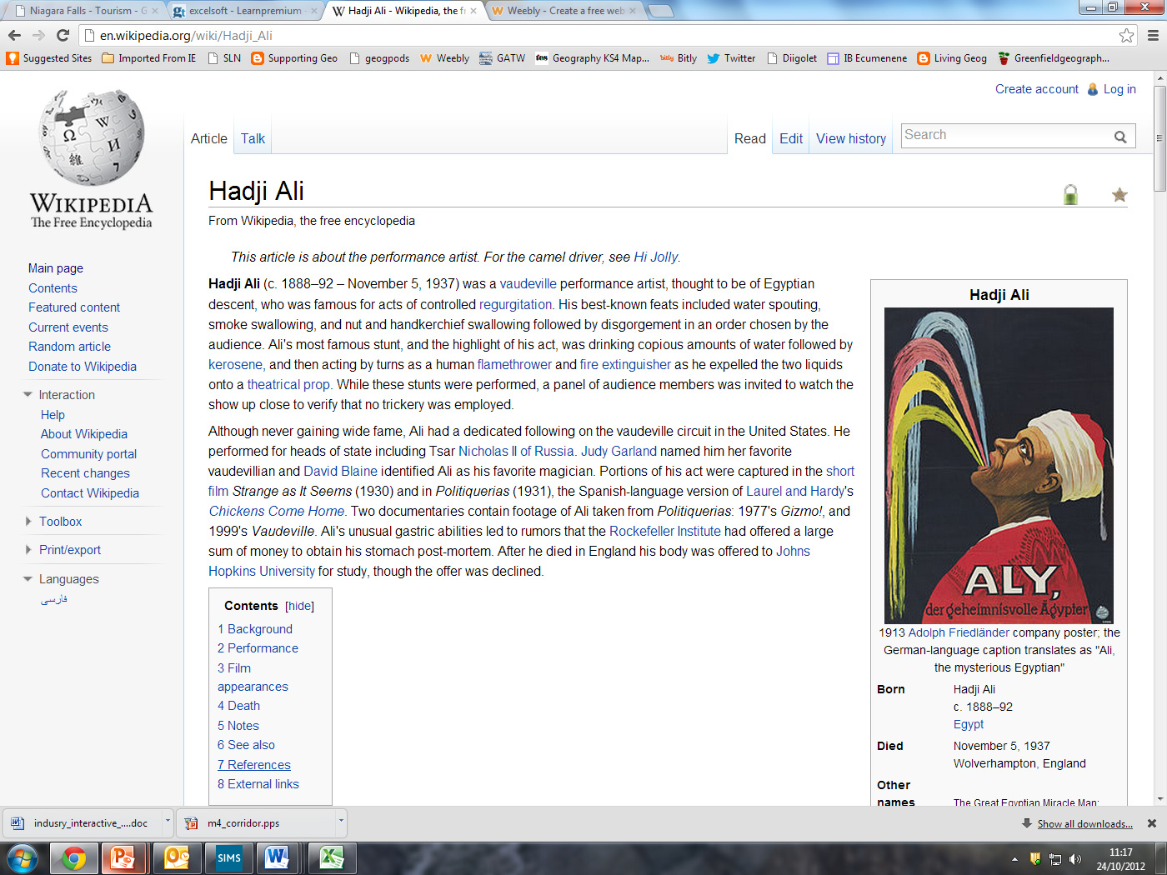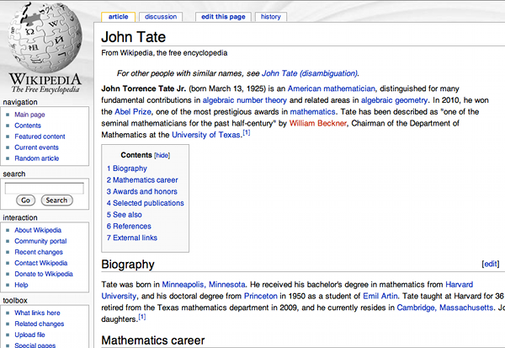

Why is Palouse Falls no longer in the same place as it was 1000 years ago? Where has it gone and what has it left behind?

Contents

Part 1 – What did Tyler do and what obstacles did he overcome ?

Typical futuristic Advert.

Biography of Tyler

Photo of Falls

Title Here