IGCSE Geography – Don’t be like Donald! (Weather & Climate)
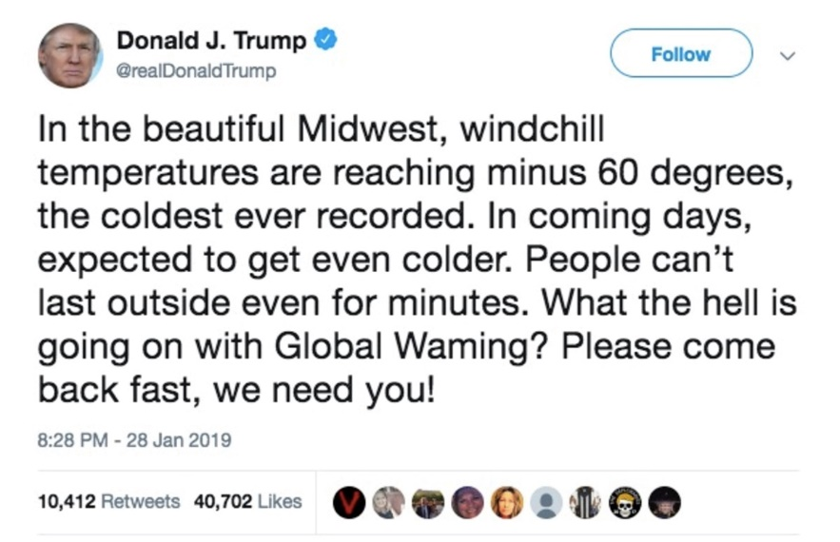

Define: Weather

Define: Climate

Tweet! Write your own Tweet back to Donald Trump to explain why his observation is incorrect.

Why is recording and understanding the weather important?

In the space below, brainstorm as many reasons as you can think of (including professions), where recording and understanding the weather is important.

