IGCSE Geography – Drainage Basin Characteristics
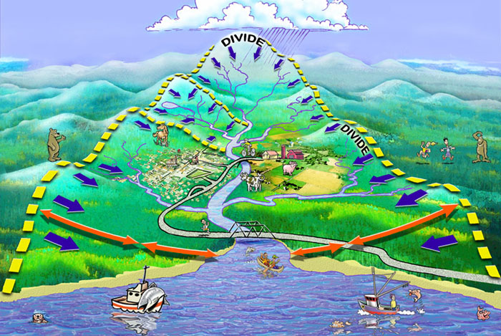

Task 1 – The diagram above shows the land based processes of the hydrological cycle (your previous lesson). It is important that you recognise the following key features of a drainage basin. Conduct some research to find out what each means and then label the appropriate place on the diagram above.
Feature | Description
- The Watershed
- Confluence
- Tributary
- Source of river
- Mouth of river

