G8 Geography – Famous Waterfalls Around the World
Complete some research to find out about the following waterfalls and complete the table.
Photo | Name | Country | Height (m) | Rank 1 - 10
 | Sutherland Falls
 | Plitvice Falls
Seljaland-
sfoss Falls
 | Yosemite Falls
 | Gullfoss Waterfall
 | Grande Cascade de Gavarnie
 | Iguazu Falls
 | Victoria Falls
 | Angel Falls
 | Skógafoss Waterfall
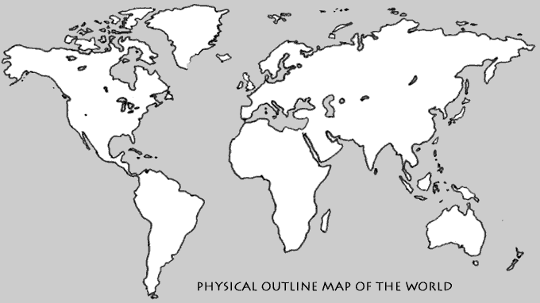
Victoria Falls & Devils Pool

Watch this 360° YouTube video about the Victoria Falls. Describe the unique nature of the waterfall and the landscape. Make sure you look all around you.

Now watch this video.

i. Why don’t the people disappear over the falls after they jump in?

ii. On a scale of 1-10, how scary would you rate this activity (0 not scary – 10 terrifying).

iii. Do you think tourists should be taking part in this sort of adrenaline activity? Explain your answer.
i

ii

iii

