G8 Geography – Waterfall Formation
Why would Palouse Waterfall not be in exactly the same place in 1000 years?

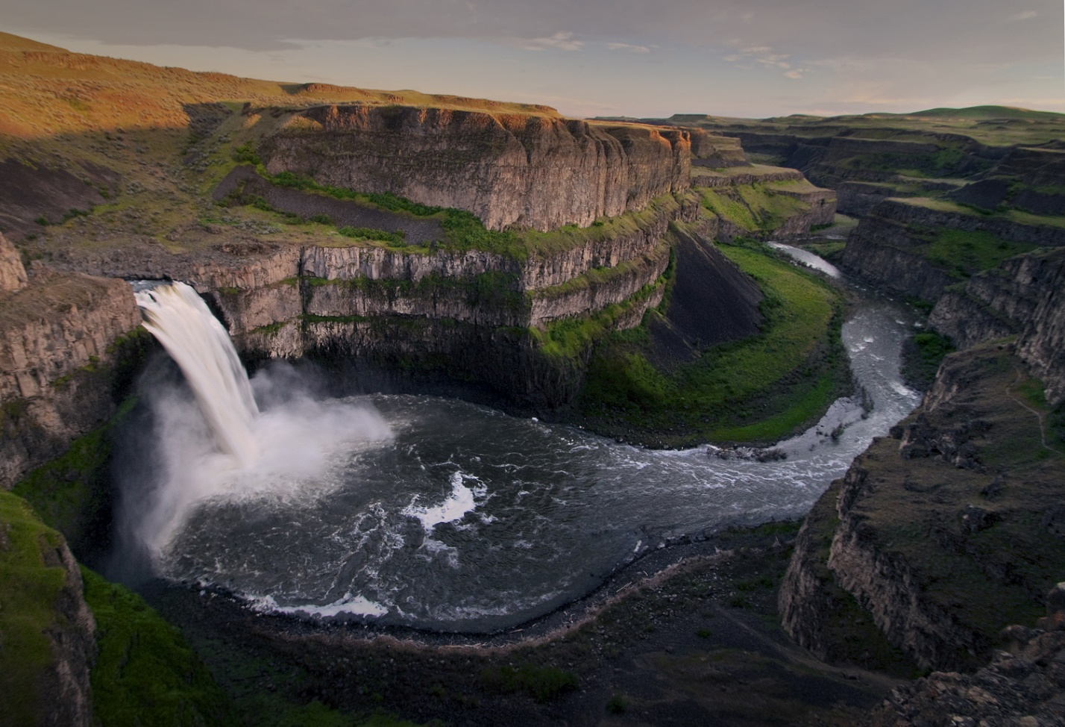

Give the locational information for Palouse Falls. (country, state, closest big city). Use the Google Map embedded on geographypods.

How high are Palouse Falls (metres)?

Watch the video of Tyler Bradt going over the edge of the falls. Write down five adjectives below to describe this extreme record attempt. Would you have attempted this?
1
2
3
4
5

Yes/No

What are the key ingredients for a waterfall to form?

Explain in 50 words how a waterfall forms. Please use the following geographical words & underline them.
Hard rock | soft rock | overhang | river | plunge pool | gravity |

Personal Geography – The last waterfall that I went to was ………

Formation of Waterfalls – In Three Cartoons

