IGCSE Geography – Who uses the water?
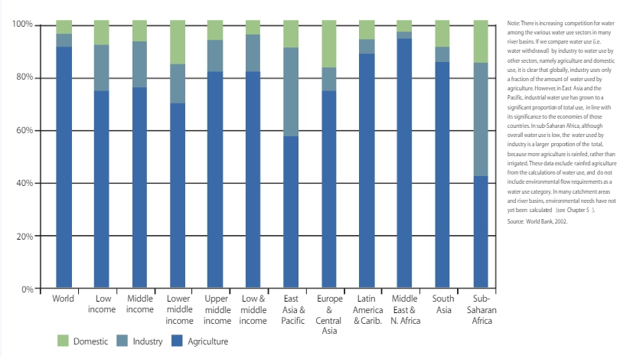
Task 3 - Study the image above (or download it by clicking on the blue tab above) and then complete the following questions.
i. Which world region uses the highest % of water for agricultural purposes? Can you think of two reasons why? Clue, think about the climate of these places…

ii. Which world region uses the highest % of water for domestic purposes? Can you give two reasons? Clue, think about how these places use water in the home…

iii. Why does East Asia and the Pacific use so much water for industrial purposes? Can you give one reason? Clue, think about where a lot of our stuff is made…

iv. Which is the only world region not the follow the global average trend of the highest % of water being used for agriculture?

