|  |
| --- |
| **Year 9 Geography – Water & Me** |

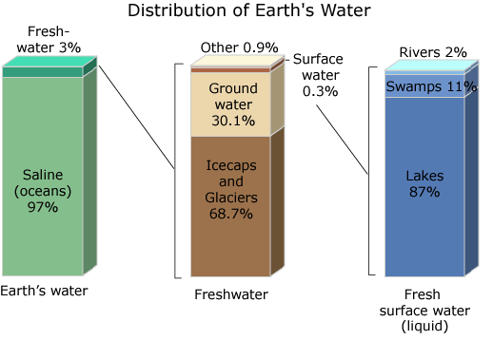

**Is it as clear as that?**

Create a piece of writing that illustrates the problem of finite clean water supply, increasing population and environmental pollution. Are there any solutions to this issue?

**So, how much do I use everyday?**

|  |  |  |  |
| --- | --- | --- | --- |
| Daily Activity | How many litres of water? | How many times per day | Total litres |
| Normal Shower – per minute | 7 Litres |  |  |
| Power Shower – per minute | 17 litres |  |  |
| Bath | 90 litres |  |  |
| Wash face & hands | 9 litres |  |  |
| Teeth cleaning – tap on | 15 litres |  |  |
| Teeth cleaning – tap off | 2 litres |  |  |
| Toilet flush | 10 litres |  |  |
| Sink wash up | 8 litres |  |  |
| Dishwasher | 50 litres |  |  |
| Food and Drink | 10 litres per day per person |  |  |
| Washing machine | 135 litres |  |  |
|  | | Total | Total |

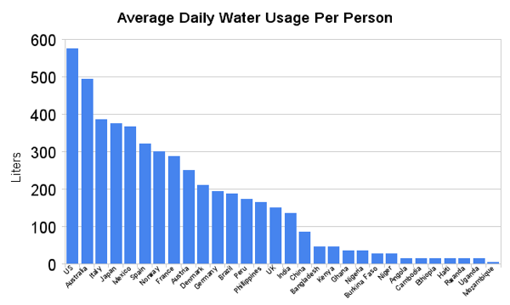

|  |  |
| --- | --- |
| The average person in the Western Europe, including France uses 400 litres of water per day. Is your total anywhere near this?  In Africa the average domestic use per person per day is 47 litres and in Asia it is 85 litres per day. In contrast in the United States people use 575 litres per day each. |  |

How do you compare with the USA, UK, Asia or Africa? Write a short account of how much water you use everyday. When and how do you use the most water? Times your daily value by 365 to give what you use in one year. Surprised??

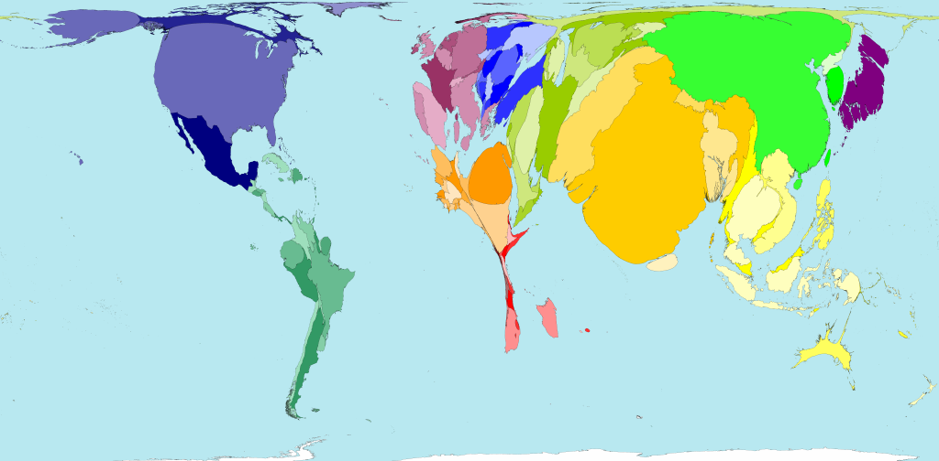

The visutal above shows water extraction and use as an inflated (high use) and deflated (low use) map. Comment on the spatial pattern of global water usage.