**Renaissance – Voyages of Discovery - Geography**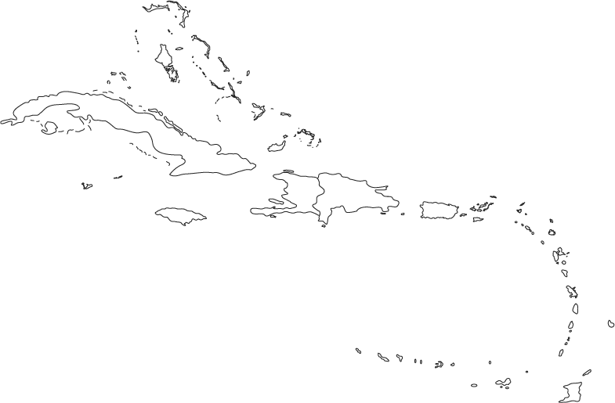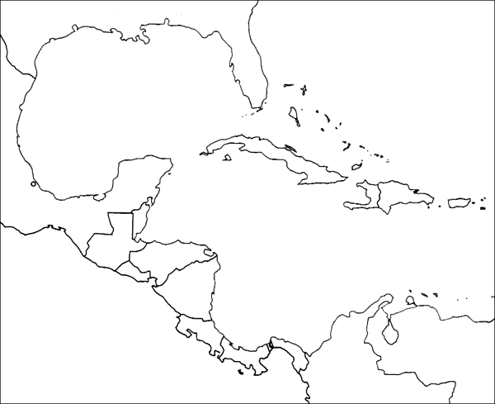

Columbus returned to Hispaniola on 19 August to find that many of the Spanish settlers of the new colony were discontented, having been misled by Columbus about the supposedly bountiful riches of the new world. An entry in his journal from September 1498 reads, "From here one might send, in the name of the Holy Trinity, as many slaves as could be sold..." Since Columbus supported the enslavement of the Hispaniola natives for economic reasons, he ultimately refused to baptize them, as Catholic law forbade the enslavement of Christians

Voyage Number 3

Dates __________

Places visited

1.

2.

3.

4.