GCSE Geography – Why are some volcanoes more violent than others?
Task: Using the www.geographypods.com site, plot the locations of the famous volcanoes onto the plate map below.
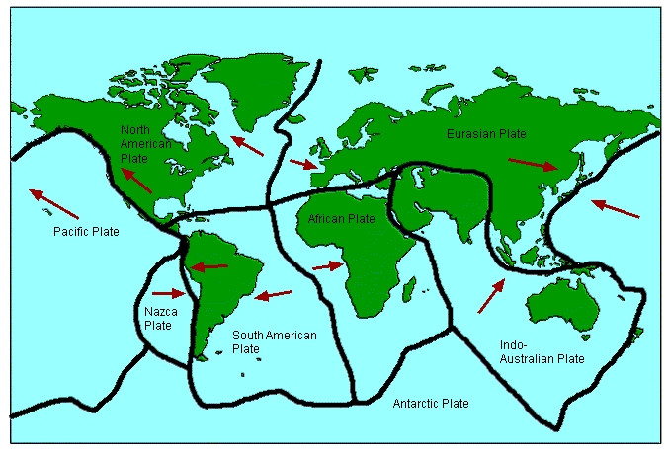
With which types of plate boundary are volcanoes mostly associated?

Image from the Geography Clinic.

