G8 Geography - My Virtual Water Footprint
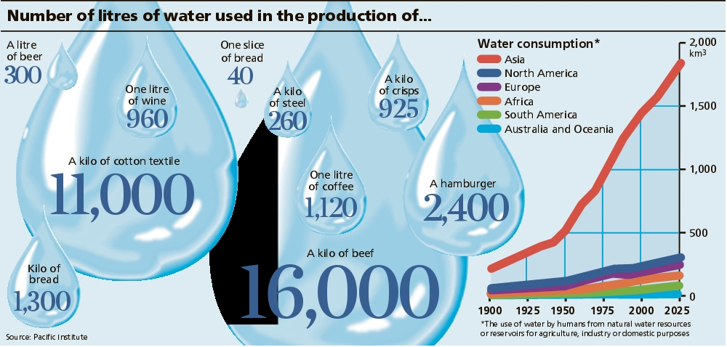
So, after working out your own domestic water consumption per day, you may feel quite happy; sitting pretty …. After all, a couple of hundred litres a day is well under the average American, right? Welcome to the world of VIRTUAL WATER!

Task 1. Mr Podbury wakes up every morning at 6am. He drags himself to the kitchen and drinks a large 250ml cup of coffee. The toaster buzzes as four slices of toast spring out and are smothered with some marmalade. A second cup of coffee (same size as before) follows before he showers and changes into his favourite shirt and trouser combination (total 500 grams) and sets off on the long drive to school. Two more 250ml coffee’s follow and by lunchtime a visit to the ‘Golden Arches’ is calling. A Double Cheeseburger with a 500ml glass of beer prepare Mr Podbury for the long afternoon in the company of G8! 3pm brings break time, a quick coffee and the last lesson of the day before he heads home to a pile of marking and his energetic children. Three friends pop around in the evening, one of whom brings a large 500-gram slice of steak, the other a one litre bottle of red wine for the BBQ. All four eat the same amount of beef and drink the same amount of wine and finish everything.

Question is, what is the virtual water footprint of Mr Podbury on this day? (btw, I would never do this normally on a school night!!). Show your working out below using the data from the image above.

Log on to the interactive water graphic on geographypods.com. Answer the following questions:
How much water do we ‘eat’ every day?

What are the two invisible aspects to our water usage? Record these two values down.

Create a flow diagram in the space underneath that shows the water footprint of 1 kilo of beef. Include all stages and values from the site.
Are there any sustainable solutions to this issue? Outline the key ideas beneath.

