IB DP Geography – Biodiversity in the tropical rainforest
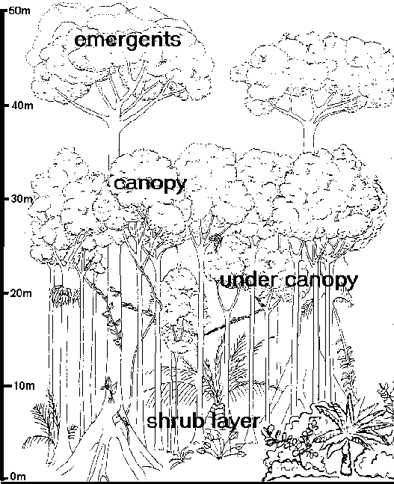
Canopy -
Emergents -

Shrub Layer
Undercanopy -

Explain the concept of Net Primary Production (NPP) p.306 Integrated Approach
1 Source - Internet Geography

The Rainforest Nutrient Cycle – Natural State | The interrupted Rainforest Nutrient Cycle - Deforested
An example of a positive or negative feedback loop? __________ | An example of a positive or negative feedback loop? __________

Using the information in Planet Geography & Integrated Approach, outline the major adaptations of vegetation to the tropical climate

