|  |
| --- |
| **IGCSE Geography – Upper Course of the River Garonne – Student Case Study Sheet** |

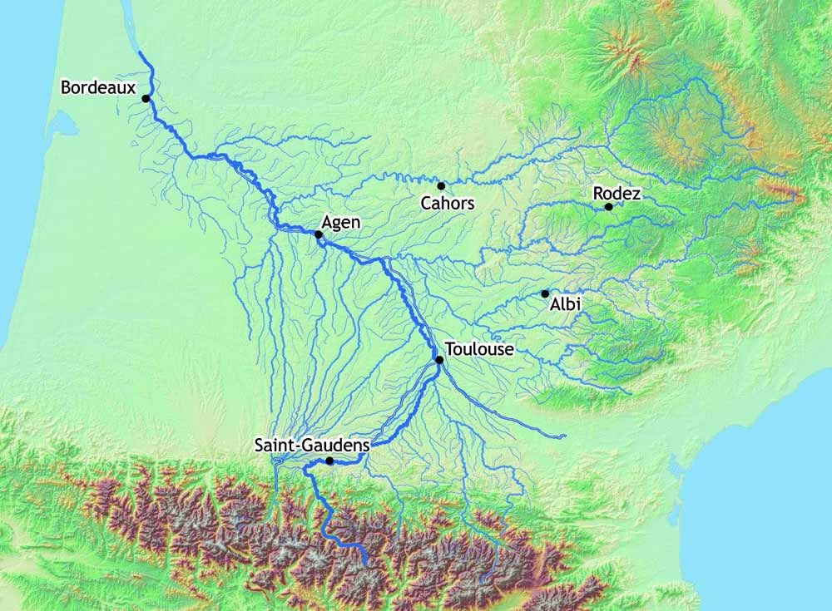

**Task 4 – 6** Diagram (waterfalls & rapid formation)

**Task 2** – V Shaped Valley

**Task 4 – 6** explanation (waterfalls & rapid formation)

**Task 1** - In the upper course of any river, ________ is always the main force because the _________ of the river is steep and it has a lot of energy, especially during _____ ______ and heavy rain.

The main process of erosion is __________ and this causes _________ and vertical erosion of the banks and the ____ of the river. Remember that the conditions in the Pyrenees can be harsh and therefore weathering can affect the slopes of the valley. Landslides and ______________ can carry materials down the slope and into the river where it is _____________ away. This often makes the valley steeper and gives it a ____________ appearance.

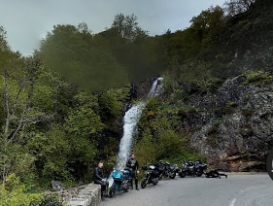

**Task 7** – Pot Hole Formation

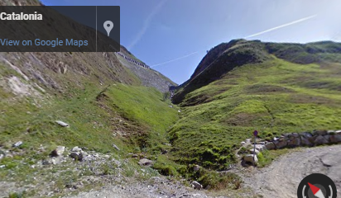

snow melt, transported, erosion, V-shaped, avalanches, gradient, abrasion, lateral, bed

**Task 3** – Describe landscape