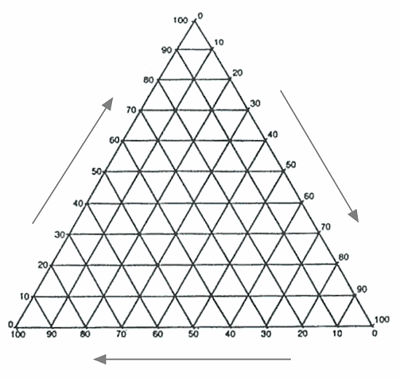
iGCSE Geography - Industry
Triangular Graphs – Plotting Employment Types.

