IB Geography - Tourism Trends – IB Response
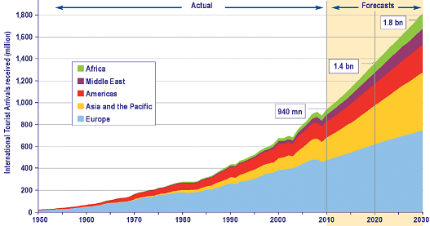
Describe and explain the projected trends in world tourism from now until the year 2030. Make reference to specific areas and tourism numbers in your response. (8)

