G8 Geography – The Impacts of Tourism in Benidorm
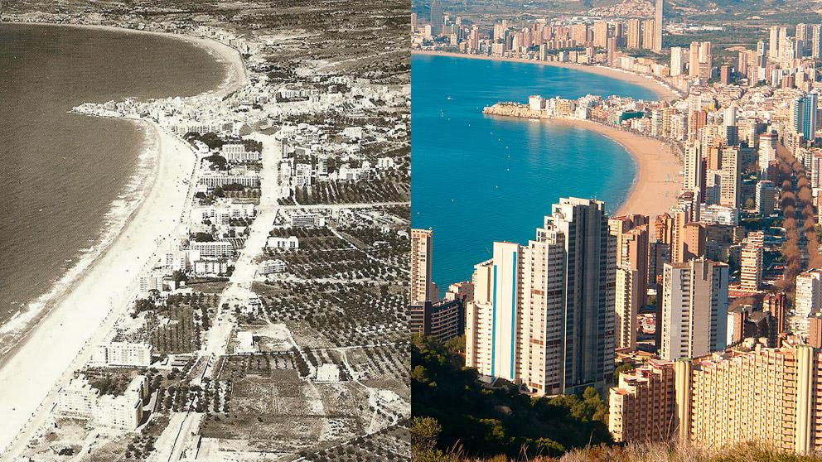

Starter: Check out the image above (source: www.lavanguardia.com). Describe the settlement of Benidorm in the old days in the photo on the left.

Describe how the settlement has changed in the second photo. Make sure you write about the size today and the type of buildings that have been constructed.

Task 1 – Watch the first video embedded on geographypods. Make a note of the physical (natural) and human attractions of Benidorm to tourists from Spain and from other countries in Europe.
Physical Attractions | Human Attractions

Would this be a place you would like to visit? Explain your answer.

Now ask a Spanish friend in the class. Would they want to go there? Why / why not?

Task 2 - Now watch the second student made video on geographypods. Write two paragraphs that explain the issues caused by too many tourists (mass tourism) on the resort.

