G6 – Tornado Chasing Task Booklet

Starter: Watch the video and write down all the important skills that would make a good storm chaser.

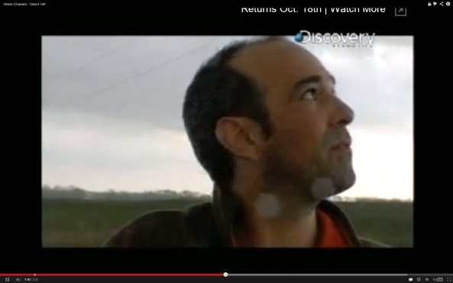

Now think of all the words to do with tornadoes/twisters and enter them in the space below:

Task – What name are you going to give your company? Enter your full name below:
__________________________________________________________________________
Choosing a location for a storm chase
Annotate on to the map where your storm chasing company will be located and explain why in the space beneath.
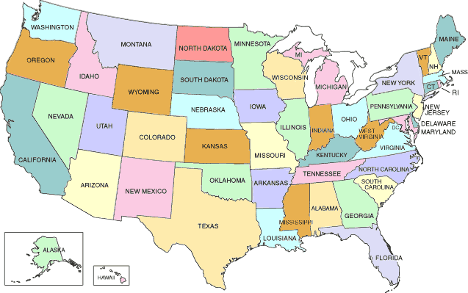
Explain why I have chosen this state:

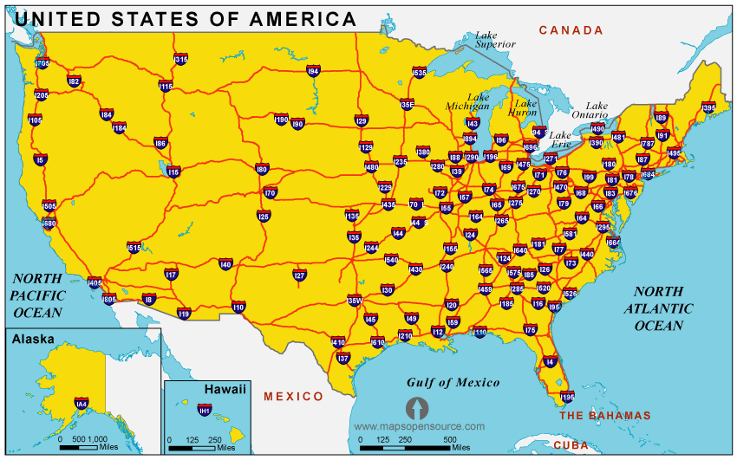
Now, using Google Maps & Street View, zoom in to your chosen state and city / town and find a suitable building to purchase and turn into your tornado chasing headquarters.
It should be near to a main road / freeway for ease of access.
It should not be too far away from an international airport.
It should have a garage to park your storm chasing vehicles.
Enter the address in the space below and save the location to your favourites.

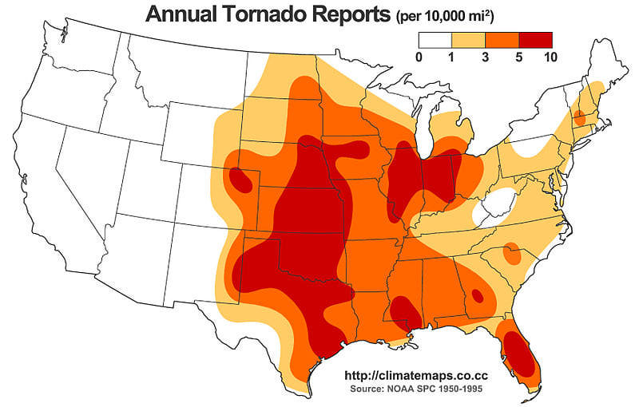

Job Advert Task
Think carefully about what you have written on page 1 of this booklet.
Storm Chaser Average Salary - $74,000 - source

Advert for My Storm Chasing Company
Guidelines:

a. Enter your company a name
b. What are Tornadoes?
c. Where do they form?
d. Why do they form?
e. When do they form?
f. How are they measured?
g. Why do people pay to ‘chase’ tornadoes?
h. What vehicles you own and how they will protect you.
i. How much does it cost for the experience?
j. Add photos, diagrams and maps
k. Add a telephone number, email address or pretend website.

Understanding a Tornado Intercept Vehicle
Task: Annotate the TIV below to show how it has been adapted to survive a tornado strike. One has been done for you. Try to identify five more.

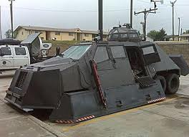

The vehicle is low to the ground so that the strong winds from the tornado don’t get underneath and flip the TIV over.

My Own TIV Design & Explanation

