Thomas Malthus – Population Size & Resource Consumption.
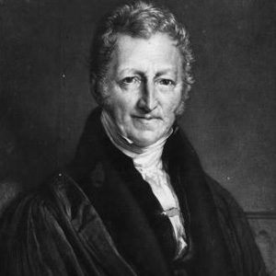

Task 1 – Watch the video on geographypods and annotate the outline graph below with information about Malthus and his predictions.

Task 2 – Outline in the space beneath the issues and controversies surrounding Malthus and his predictions.

Task 3 – Create an annotated person fact file in the space below about Thomas Malthus and about his population predictions back in the year 1798. Use the embedded resources on geographypods.

