The Kayapo Indigenous People of Brazil
Name:

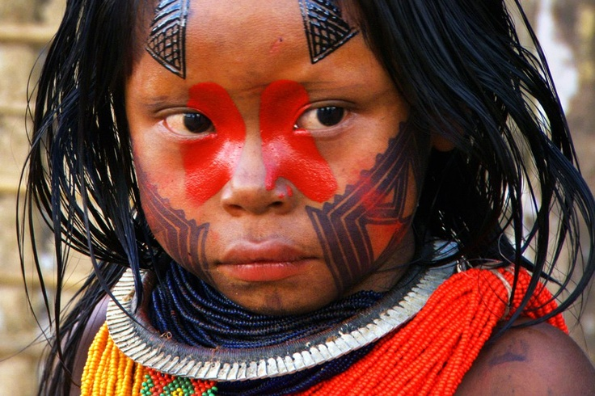

Create a spider diagram below to show how the Kayapo use the forest.

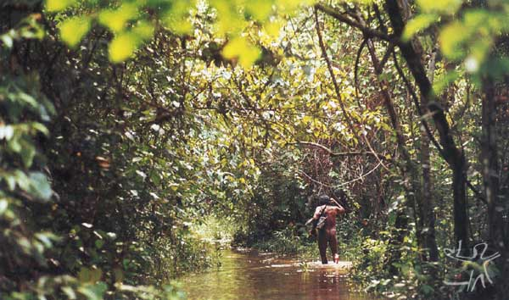

Now complete a piece of writing to explain how the Kayapo look after their forest.

Notes on the rest of the video.

