What should “we” call “them?” – The Four Gapminder Levels
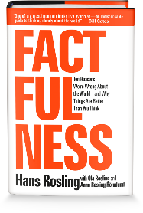
Factors | Level 1 | Level 2 | Level 3 | Level 4
Population

Income in $

Energy

Water supply

Transportation

Education

Other important information

