G12 – Core - The Atmospheric Energy Budget
The earth and its atmosphere constantly receives solar radiation but there are long and short term variations in the earth's climate & recent decades have seen the general rise in global temperatures.
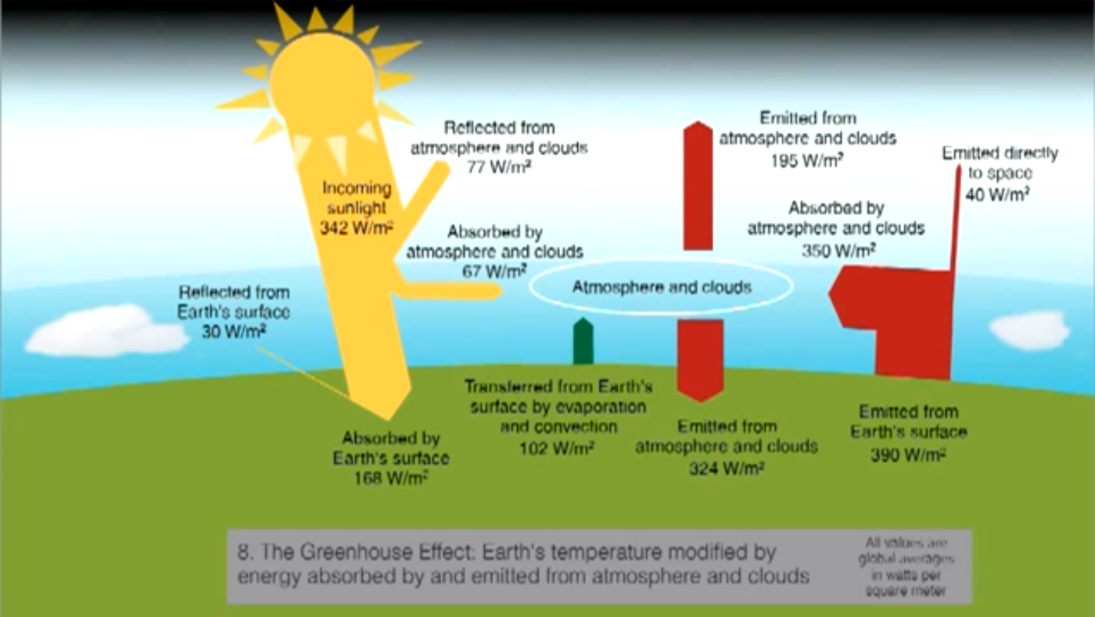
Task – Describe the earth's energy budget and explain how the enhanced greenhouse effect causes positive feedback to occur within the system. (8)

Response here

