G6 Geography – Globalization & Trade
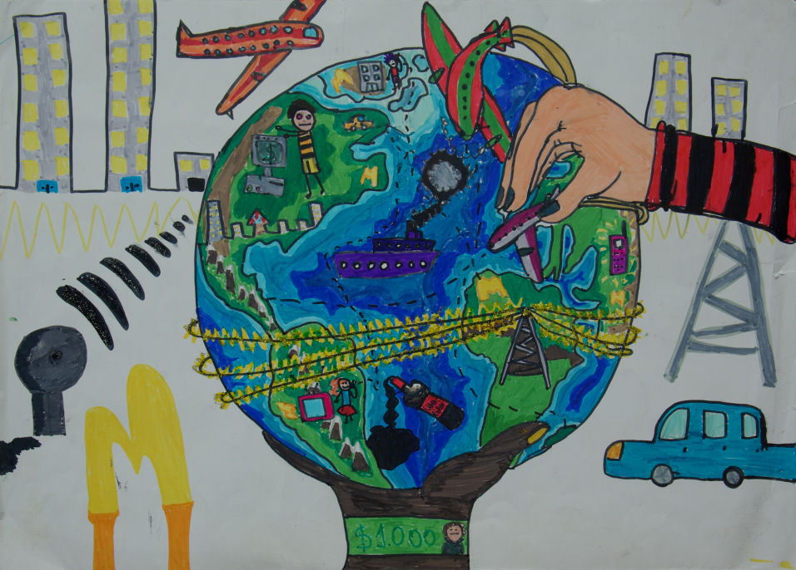
i Globalization – Watch the embedded globalization video on geographypods and complete the note taking framework below.

0:23 | What four things have helped to advance globalization in recent years? | 1  2  3  4
0.49 | What does the term globalization mean?
0.56 | Where did companies used to manufacture (make) their products?
1.24 | What has changed now? Where might our products come from?
 | What effect does this have on the price of the goods that we buy?
2.00 | What five things can happen as a result of these exchanges of products? | 1  2  3  4  5
2.20 | Explain how globalization can affect jobs in rich and poor countries.
2.43 | Explain the issues about wages paid to people who make our stuff in poor countries.
3.00 | Explain how globalization can contribute to environmental (ecological) damage.

ii. Trade – Please write down six products that France imports from other countries. You can write the name of the item inside the arrow (and add the name of the country where it comes from).

ii. Trade – Please write down six products that France exports to other countries. You can write the name of the item inside the arrow.

iii - Read Paul Salopek’s blog post from Out of Eden Walk titled “Relic Walls of the Ancient Silk Road.” It is hyperlinked on geographypods. There is a short video to watch too.

What were some of the positives outcomes of the globalization encouraged by the Silk Road?
What were the negative outcomes?
Did the positives outweigh the negatives?

iii. Trade Wars – Using the BBC Newsround article complete the questions below.

What is a trade war?
Which two countries are currently engaged in a trade war and why?
What is a tariff?

Above are two global companies that you should know well (perhaps one better than the other!). Carry out some research and find out why the European Union and The United States are involved in a trade dispute because of these two companies. Summarise your findings in about 100 words in the space below.

