IGCSE Geography – Water Tanzania (Issues & Supply)
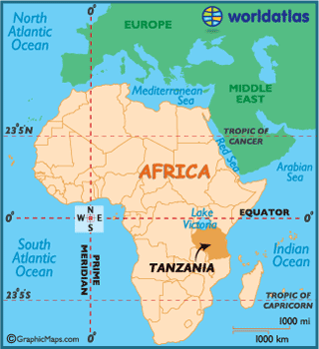
Write a description of the location of Tanzania
Refer to one line of latitude, at least two directions (NESW), an ocean, a physical feature.
Watch the video ‘Tanzania: The Long Walk for Water’

How far do the Maasai have to travel each day to find water in Tanzania?

The problem of water scarcity has been made worse by which global issue?

What problems does a lack of water also cause within communities?

How far under the ground is the water in this part of Tanzania?

How has a permanent water supply (borehole) changed the life of the Maasai in this part of Tanzania?

Now watch the video WaterAid Tanzania: Five Villages Water Scheme Project

0:00 - Outline the issues faced by women in this part in Tanzania when trying to collect water.

1:15 - Describe the two methods that the project uses to supply freshwater. Explain briefly how the water is cleaned.

3:14 – Briefly explain how this process is powered (note the link to your previous unit of work on energy).

4:30 – Explain how the e-water system works and how people can pay for their clean water supply.

6:03 - What are the dangers of having too much fluoride in the water supplies?
FINISH 6:37

In summary - A protected borehole is drilled 100m down into the earth to reach a water source.

A solar panel made of photovoltaic modules powers an electric motor - which in turn powers an underground water pump. This pump can draw up to 30,000 litres of clean, fresh water, every single day.

All of this fresh water is stored in a water tank. The tank is then connected to water pumps and taps around the village by a system of pipes.

Local villagers are then able to access fresh, clean water without having to travel long distances, and can use their e-water payment system to access the resource 24 hours a day.

Families now have that most basic need - to be able to drink clean water. They can enjoy a life free from the constant fear of water-borne diseases.

Also, because they no longer need to spend hours searching for water, children have the time to go to school and women can grow vegetables to sell at the local market.

