IGCSE Geography – Agriculture – Subsistence Farming
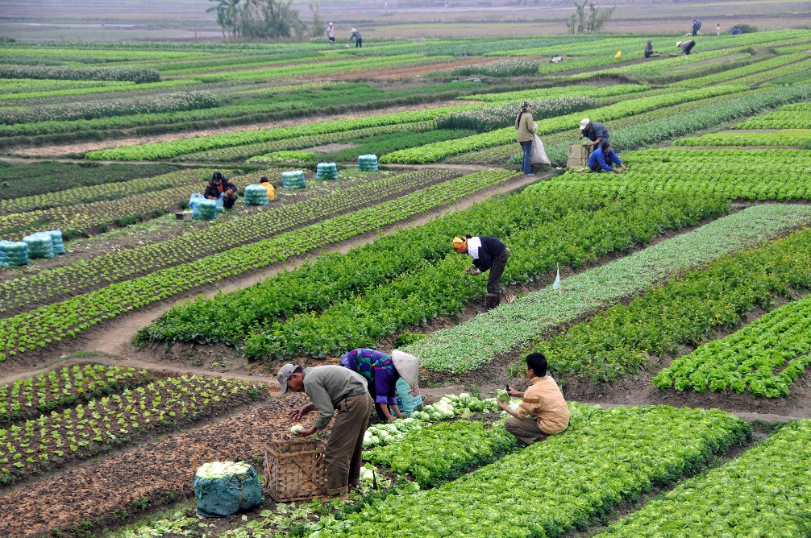

Outline how subsistence farming is different to large scale commercial farming. Use the image above as a starting point, especially considering what you have just learnt about Fair Oaks Farm in the USA.

Watch the second YouTube video I'm a Subsistence farmer, get me out of here.
- Outline the reasons why people find subsistence farming hard in rural parts of Ghana.

- ii. Why do these people move to the shanty towns in the urban areas? (link with NIC Urbanisation)

