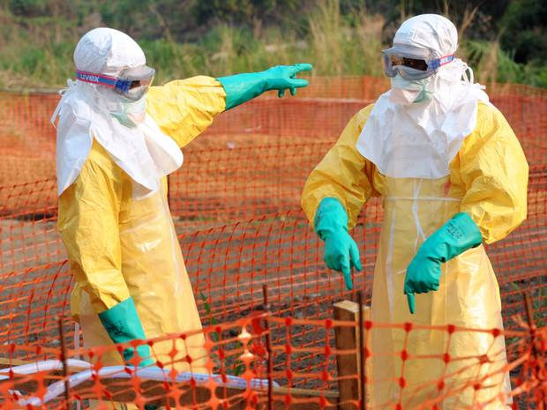
Geography for 2014 & Beyond

The Ebola Virus 2014
"A very dangerous virus got into a place in the world that is the least prepared to deal with it,"
Daniel Bausch - Tropical Medicine Researcher at Tulane University
Name:
Geography Teacher:

The tasks in this mini unit of work are based on the resources on http://www.geographypods.com/ebola-2014.html
Starter: Watch the BBC News 60 second fact video on Ebola. Fill in the diagram below. How much can you remember about what you have just seen?
How is Ebola spread?
What are the five Ebola symptoms?

When & where did Ebola first appear?
What does Ebola attack?

What is the cure for Ebola and what % of people die?
How are affected patients treated and what does this prevent?

Task 1 – Where did Ebola come from?
Using the link on geographypods, write an account below of where scientists think the Ebola virus came from and how they know.

After watching the Hans Rosling video, explain beneath how he think that the Ebola virus continued to spread in West Africa.

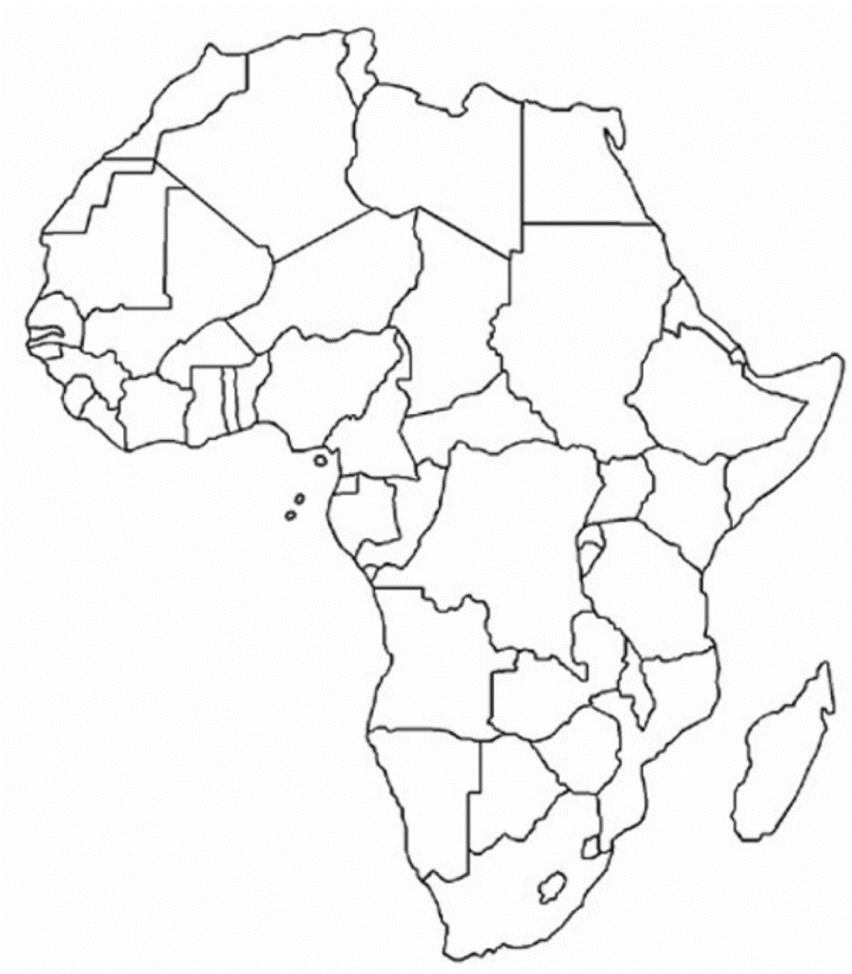
Task 2 – Mapping the historical spread of Ebola
Using the same webpage as task 1 and an atlas, shade in the countries affected as follows:
1976 – Shade in yellow & add name of countries affected.
2005 – Shade in orange & add names of countries affected.
2014 (current Ebola outbreak) – Shade in red and add the names of countries affected.

Task 3 – Just how bad is Ebola?
- What are the top three most deadline virus outbreaks of all time?

- What are the three main ways that viruses can be transmitted and which one is responsible for the spread of Ebola?

- What is the general relationship between the most deadly diseases and how they are transmitted?

Task 4 – How deadly is Ebola?
- What percentage of people with Ebola died in the 1976 outbreak?

- What percentage of people with Ebola have died in the current outbreak?

- Why do you think this figure is less now than in 1976?

Task 5 – What are the signs and symptoms of Ebola?
Using the two images on geographypods, annotate the symptoms onto the person outline beneath. You should include extra annotations to show the timescale involved in some of the symptoms.

Task 6 – How to avoid catching Ebola.
- Using the information on the web link on geographypods, annotate and explain the precautions that the health worker below is taking to avoid catching Ebola.

- Many aid workers from different countries around the world have travelled to and worked in infected areas to help people with the disease. Would you go to West Africa? How would you feel if you were in the situation above?

- How many people, on average, does each person with Ebola infect?

**Update October 2014** Our closest case of Ebola is currently in Madrid, Spain. A nurse in a hospital there has contracted the virus from two missionary priests that she was treating. Read the BBC article from 8th October here and write down below how she contracted the virus.

Task 7 – Is Ebola only deadly to the poorest?
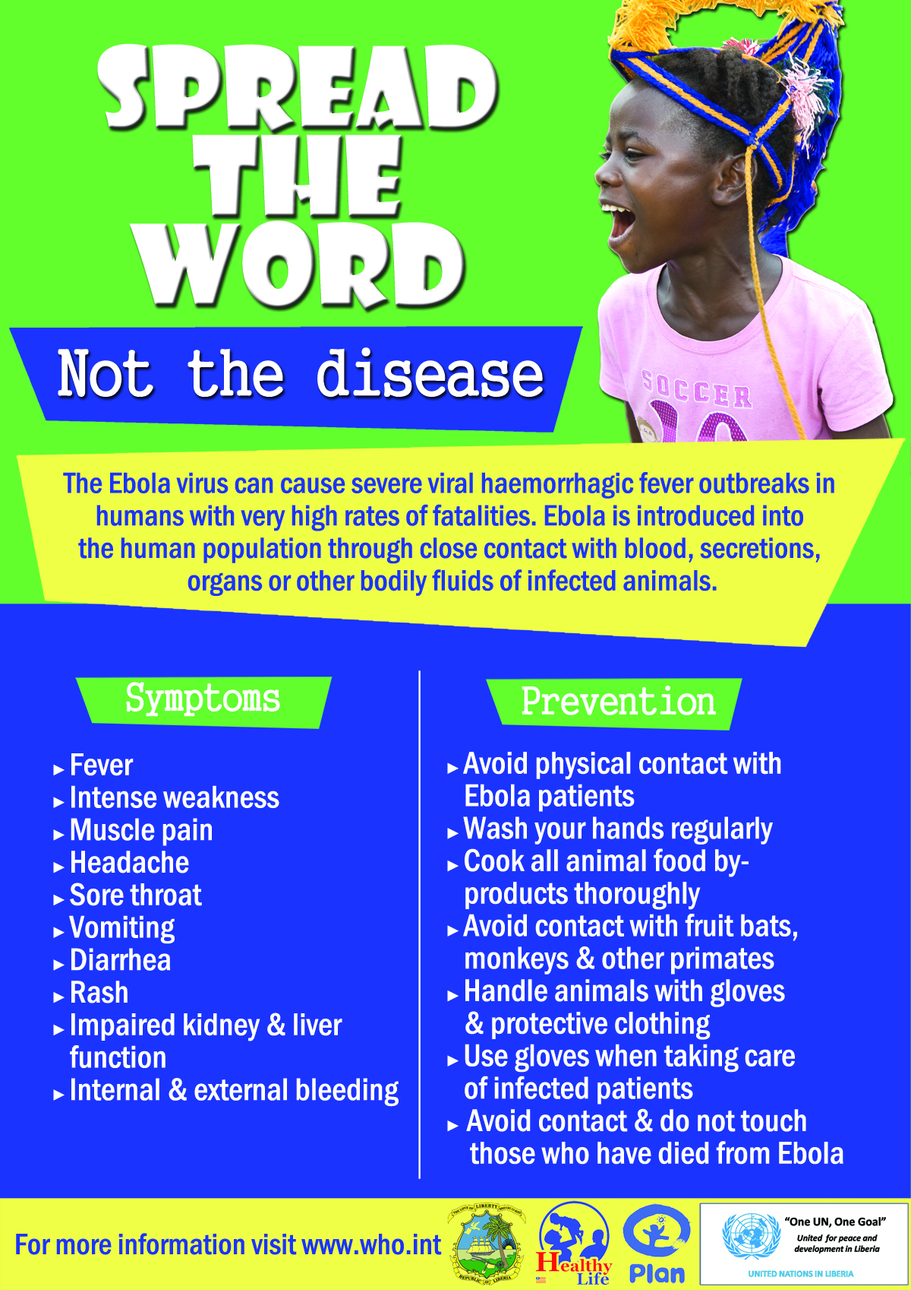
Complete a piece of extended writing (500 words) on Microsoft Word using the title above as your focus.
Things to think about
- Levels of poverty & cost of medicines like ZMapp
- Level of development (rich – MEDC or poorer – LEDC) and healthcare
- How likely are we to have a big outbreak of Ebola in our country and how we would deal with it (USA, UK, Spain)
- Carrying out some research and find out how the spread of Ebola can be slowed down or stopped completely. Write about which bits of advice would be best suited to your home country.
Essay – Target 500 Words

