Key Stakeholders – Starbucks in Carcassonne La Cité
I am Adeline - a town planner who works for Carcassonne Town Hall. The three properties that have been chosen as possible locations are all derelict (unused) and are falling into a state of disrepair. We have not had any other applications to use the buildings and are worried that these premises may fall further into a state of ruin. This will ultimately have an impact by reducing the visual appeal of La Cité. We have an agreement that Starbucks would only use minimal signage and no bright colours or lights outside the chosen venue.

Adeline - Town Planner

Key Stakeholders – Starbucks in Carcassonne La Cité
I am Isobel, an advisor for UNESCO. The Committee decided to inscribe Carcassonne considering that the historic town is an excellent example of a medieval fortified town whose massive defences were constructed on walls dating from Late Antiquity and that the site remains in a semi authentic state. We absolutely reject the application by Starbucks to open a coffee house in the centre. This would ruin the historical image of Carcassonne and not fit in at all with the other businesses. It may also increase incidences of litter and take away business from other authentic French providers in La Cité. Reject the proposal at all costs or we may reconsider the UNESCO inscription.

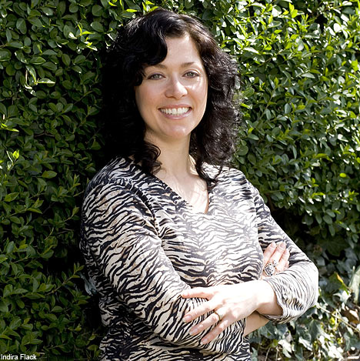

Isobel – UNESCO Advisor

Key Stakeholders – Starbucks in Carcassonne La Cité
I am Guillaume, a resident of La Cité near the planned Starbucks development. I have lived here all of my life and since I have been retired, I go to the same French café owned by my friend, Jean Marc every day. If Starbucks opens in La Cité, it will ruin the café culture in Carcassonne. Starbucks doesn’t belong in a place like this as it’s a relatively new American coffee company with no link to France or Carcassonne at all. No McDonalds, no Starbucks, no Burger King!! End of.

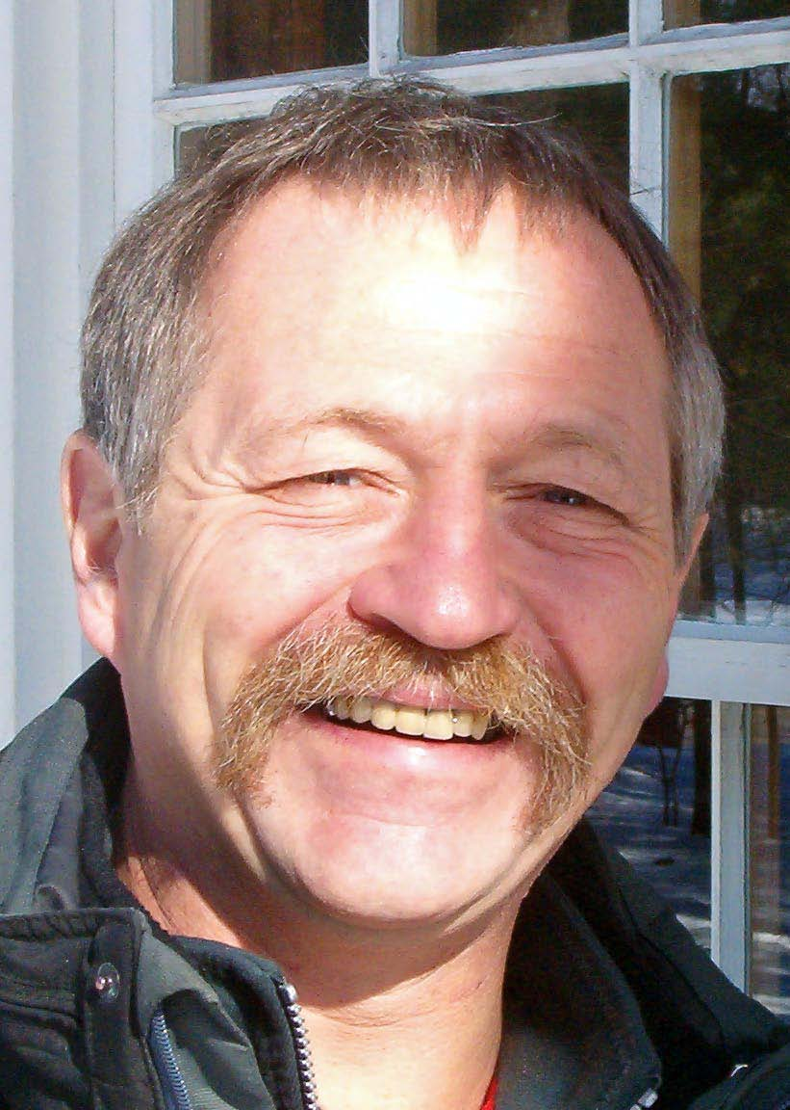

Guillaume - Local Resident

Key Stakeholders – Starbucks in Carcassonne La Cité
I am Marie Anne, an unemployed person living in Carcassonne. You do know that there is an economic recession at the moment? I used to work in a hotel in Carcassonne new town. It closed down in 2013 because of bad reviews. Since then, I have been looking everywhere for a job but with no luck. There are lots of jobs in Toulouse but it would cost me money on the train to get there every day. I could get a job in a new Starbucks and could cycle to work too. I would then have a job and could afford to buy my own apartment in Carcassonne.

Marie Anne
Unemployed

Key Stakeholders – Starbucks in Carcassonne La Cité

I am Paul, a Year 10 student living with my parents inside La Cité. Although a beautiful place, there is very little for young people like me to do. Shops full of souvenirs, expensive ‘tourist trap’ restaurants and annoying tourists taking pictures of everything and anything that moves! It is really, really annoying at times. It would be great to have a Starbucks here. I could meet with my friends there, they’ve got free WIFI and so I could spend time there chilling out without having to walk all the way down into the new town …. and then back up again! Come on Carcassonne, it’s 2015 not 1915!

Paul - Local Teenager

Key Stakeholders – Starbucks in Carcassonne La Cité

I am Jean Marc, the owner of three café’s in La Cité.
I pay an absolute fortune to rent out my three café spaces in the centre of town. My main product is coffee and this is also very profitable as it has a high mark up value. I employ 14 people directly in all three establishments. A Starbucks will be a very unwelcome addition to La Cité and would put my longstanding business in real jeopardy. Surely, people coming to France want to experience the real French café culture not a New York style coffee house!

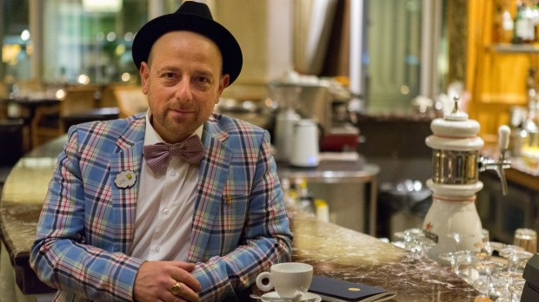

Jean Marc – Cafe owner

Key Stakeholders – Starbucks in Carcassonne La Cité

I am Louis, the manager of Starbucks in the South West of France. People like our products because they can buy a coffee and cake in comfortable surroundings. Our outlets offer a place of relaxation with a feeling of a modern yet sophisticated environment. Our clientele ranges from the young to the old and our product range reflects this. We have heard the complaints from the French café bar owners and frankly, they shouldn’t be scared of the competition. They have had a long standing monopoly on the café culture in France and their stale, lifeless bars need a serious upgrade to reflect the needs and expectations of coffee drinking customers.

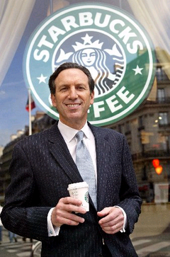

Louis – Starbucks Rep in SW France

Key Stakeholders – Starbucks in Carcassonne La Cité

My name is Gérard Larrat and I am the mayor of Carcassonne. Carcassonne is one of the biggest tourist attractions in France and we have worked hard to build up its reputation. Tourists visit us from all parts of the world (as you found out on your own recent visit to my town). All these extra people need facilities and leisure activities to do and it ultimately creates more jobs. As long as our economy is booming and both locals and tourists are being looked after, I am happy. However, I want to also promote the ‘Buy French’ idea and so I have been reluctant in the past to give my approval to other USA organisations. In fact, they are only allowed on the outskirts of the town in retail parks.

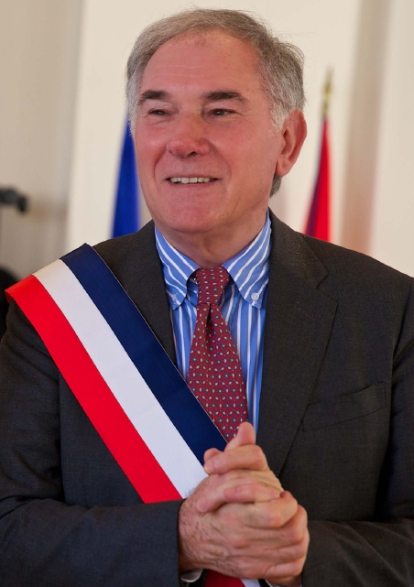

Gérard – Mayor Of Carcassonne

