IGCSE Geography – Coastal Processes - Formation of a Spit
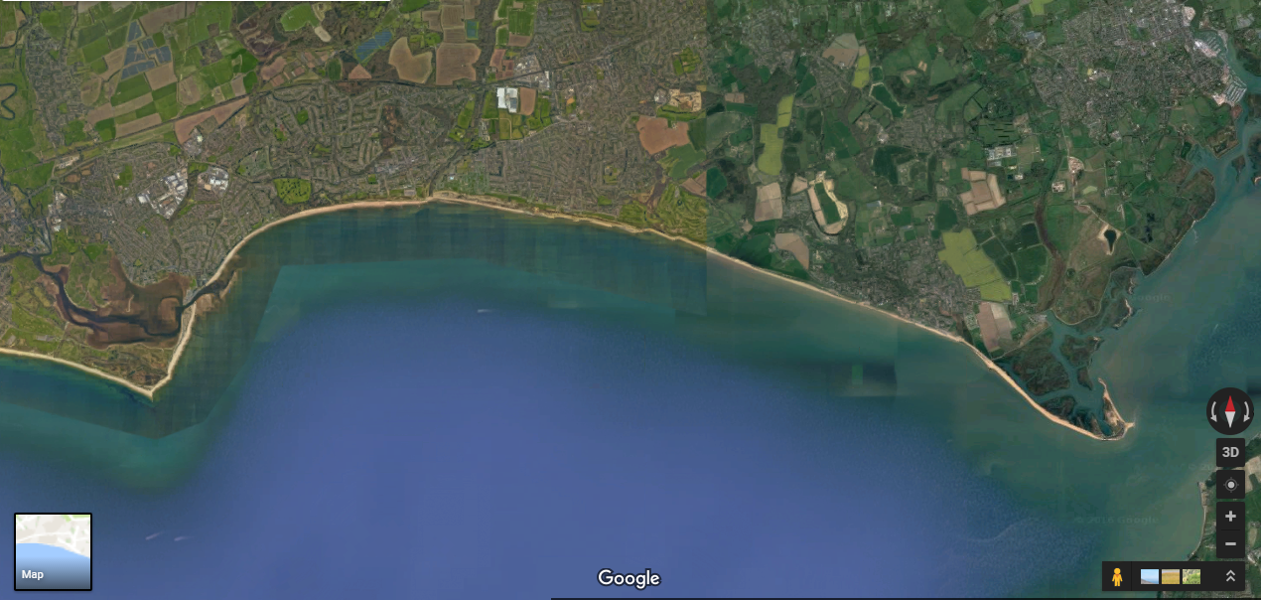
Task 1 – The Google Satellite image above shows you Hurst Spit on the south coast of England close to the town of Bournemouth. Watch the video embedded on geographypods.com and try to label the processes on your image above by hand.
Source of sediment – can you label the river that provides the sediment to be carried along the coastline - Longshore drift (transportation) – draw the movement along the coastline - Bend in the coastline - Formation of Spit including curvature (deposition) - Build-up of sediment (deposition) behind spit & formation of salt marsh - Narrowing of the estuary mouth.

