G8 Geography – Should We Ban Billionaires?

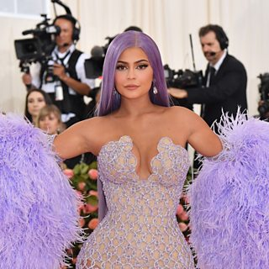

How did the owner of Ikea get so rich?

Apart from Royal families and dictators, how many billionaires are there in the world?

Part 1 – ‘There Are No Angels’. Listen to Dr Paul Segal and make a note of the key things that he says.
Ban or not?

Part 2 – ‘The Fields & The Lanes’. Listen to Roxanne Roberts and make a note of the key things that she says.

Ban or not?

Part 3 – ‘The Makers & The Takers’. Listen to Caroline Freund and make a note of the key things that she says.

Ban or not?

Part 4 – ‘Consenting Adults’. Listen to Will Wilkinson and make a note of the key things that he says.

Ban or not

Your thoughts. What should we do with billionaires (in 50 words)?

