GCSE – Geography - Is there a pattern to shopping ?
Type s of goods
High order goods are:

Low order goods are:

1960’s to 1970’s Modern Shopping

CBD is no longer at the top of the hierarchy because…

The number of corner shops has declined because…

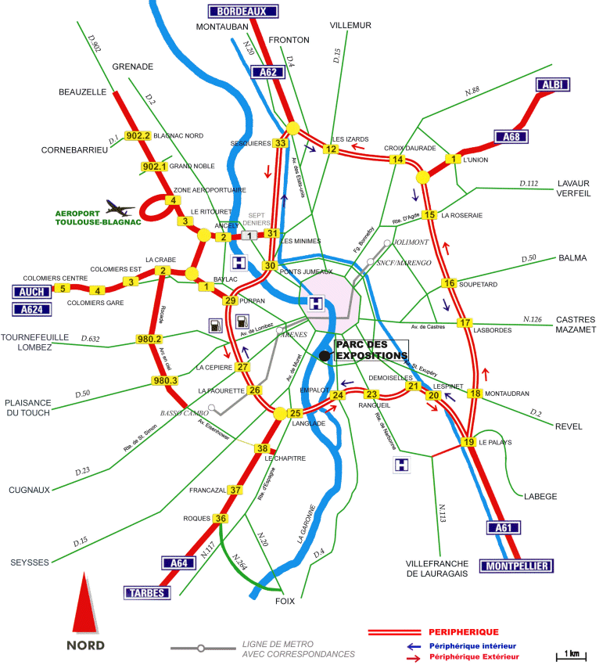
Complex Consumer Landscapes
Toulouse CBD

