**Geography GCSE**

Sustainable Decision Making Exercise (SDME)

June 14th 2010 9am

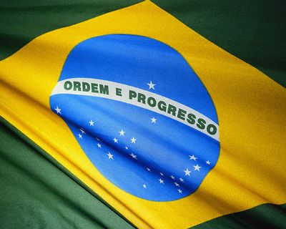

**Economic**

**Development**

Name :

Form :

Geography Teacher :

**Glossary**

**Multinational Company (MNC):** Business enterprise with manufacturing, sales, or services in one or more foreign countries.

**Newly Industrialised Country (NIC):** Country formerly classified as less developed, but which is becoming rapidly industrialised.

**Subsidy** : a form of financial assistance paid to a business or economic sector. Most subsidies are made by the government to prevent the decline or encourage the growth of an industry

**Import** : to bring in (goods or materials) from a foreign country for trade or sale.

**Export** : to sell or transfer (goods or services) abroad

**Devalue** : lower the value or quality of

**Free Trade Zone** : A free trade zone (FTZ) or export processing zone (EPZ) is an area of a country where some normal trade barriers (tariffs and quotas) are eliminated in the hope of attracting new business and foreign investments

**Trade Union** : Workers organised into a voluntary association, or union, to further their interests with respect to wages, hours and working conditions.

**Gross National Product (GNP)** : Value of all goods and services produced in a country in one year

**Customs Duties** : Taxes or charges added to goods as they enter or leave a country

**Formal Sector** : the employment sector comprising 'proper' jobs that are usually permanent, with set hours of work, agreed levels of pay, and sometimes pensions and social security rights.

**Informal Sector** : Unofficial sector of underground employment beyond government regulation and taxation.

**Prosperity** : an economic state of growth with rising profits and full employment .

**Foreign Nationals** : An individual that is any nationality apart from that of the country they are living in.

**Multiplier Effect :** the 'snowballing' of economic activity. e.g. If new jobs are created, people who take them have money to spend in the shops, which means that more shop workers are needed. The shop workers pay their taxes and spend this money, creating yet more jobs.

**Economic Base** : the companies and industries that residents depend on to earn a living.

**Economic Recession** : is a general slowdown in economic activity over a long period of time.

**Prestige Value :** high status or reputation achieved through success, influence, wealth, etc…

**Mechanisation** : the use of machines to replace manual labour or animals.

**Turnover** : The total money value of all sales and purchases for a business in a given time period.

**Equal Opportunities** : The granting of equal rights, privileges, & status regardless of gender, age, race, religion, disability, or sexual orientation.

**Tax Holidays** : A tax holiday is a temporary reduction or elimination of a tax. Governments usually create tax holidays as incentives for business investment

**Relocation :** move: the act of changing your residence or place of business

**Groundwater :** Water that exists beneath the earth's surface in underground streams and aquifers.

**Pesticides** : A chemical used to kill pests (such as rodents or insects).

**Public Relations (PR)** : is the practice of managing the communication between an organisation and the public.

**Trade Barriers** : Trade laws (often tariffs) that is favouring local firms and discriminating against foreign ones.

**Autonomy** : Independence

**High Import Tariff Barriers** : high charges imposed on imported goods that act to encourage the local economy.

**Resource 1 - Logos**

**TASK** **1** - Select 2 MNCs from each row. Add their details into the table below.

|  |  |  |  |  |  |  |
| --- | --- | --- | --- | --- | --- | --- |
| **MNC Name** | **Country** | **Continent** | **MEDC or LEDC?** | **Locations in (Countries)** | **Continent(s)** | **MEDC or LEDC?** |
|  |  |  |  |  |  |  |
|  |  |  |  |  |  |  |
|  |  |  |  |  |  |  |
|  |  |  |  |  |  |  |
|  |  |  |  |  |  |  |
|  |  |  |  |  |  |  |

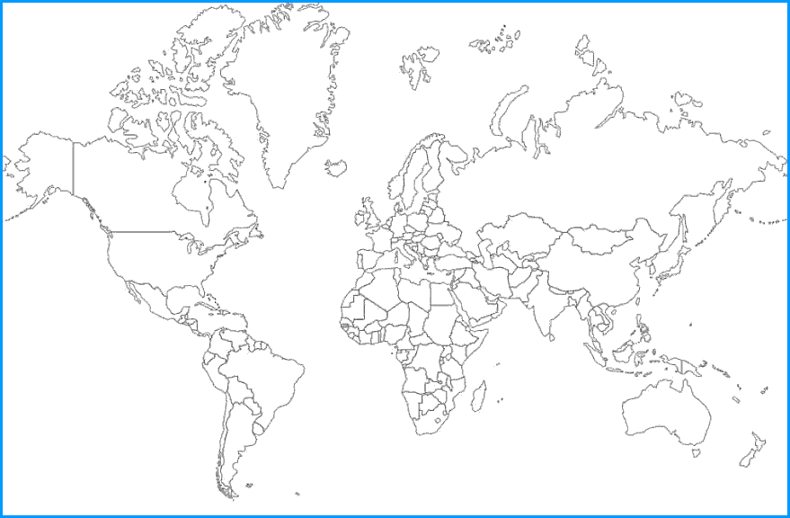

**Question 1**

**TASK 2**

Add labelled arrows to the map to show MNC countries

= MNC Country

Draw a line to connect them to their location countries. Name these.

= Locations in.

Describe the location of the headquarters of MNCs around the world. (4)

(Use the words **MEDCs. Europe. Japan. North America**.) __________________________________________________________________________________________________________________________________________________________________________________________________________________________________________________________________________________________________________________________________________________________________________________________________________________________________________________________________________________________________________________________________________

**Resource 2 – NIC governments attracting MNCs**

**TASK 1**- Label the statements as **ECONOMIC** or **SOCIAL** factors in the left hand column.

Then write the correct statement from the black boxes below in the **EXPLANATION** column.

|  |  |  |  |
| --- | --- | --- | --- |
| **Economic or Social?** | **Way** | **Detail** | **Explanation** |
|  | Cheap loans and subsidies | Given to new industries |  |
|  | Restrict Imports | Protect own industries from competition |  |
|  | Devalue Currencies | Make exports cheaper |  |
|  | ‘Tax Holidays’ for overseas firms | No tax to pay for several years |  |
|  | Free trade zones set up | No customs duties |  |
|  | Trade Union Activity | Strikes banned |  |
|  | Health and Safety regulations | Not enforced in many factories to cut costs |  |
|  | Education and Training | Prioritised to attract foreign companies |  |

This means that MNCs will have money to invest in training, factories and equipment.

Having a trained and skilled workforce is important to MNCs.

Having a peaceful and obedient workforce is attractive to MNCs.

Allowing cost-free passage of goods out of the NIC will encourage investment.

Saving money by not enforcing safety rules will be beneficial to MNCs.

Allows MNCs to make more profit and encourages other countries to buy goods from NICs.

By stopping foreign imports, this will support local businesses and MNCs.

Paying no tax is a huge incentive for MNCs. It will save them lots of money.

**Question 1**

1. Identify and explain ONE economic factor and ONE social factor that would attract MNCs to NICs (4)

Economic Factor ___________________________________________________________________________________________

Explanation________________________________________________________________________________________________________________________________________________________________________________________________________Social Factor _________________________________________________________________________________________________________Explanation________________________________________________________________________________________________________________________________________________________________________________________________________

1. Describe what has happened to the population growth in the informal and formal sectors (2) ________________________________________________________________________________________________________________________________________________________________________________
2. Describe how the proportions of each section have changed over time(2) ________________________________________________________________________________________________________________________________________________________________________________

**Resource 3 - Advantages and Disadvantages of MNCs**

**TASK 1 – IN YOUR BOOKLET,** label each of the Advantages in order of their importance (e.g. A1 – The most important, then A2 etc.._). Now do the same for the Disadvantages (D1 etc…)

Add the labels (A1, A2 . . . D1, D2 etc…) into the appropriate bubble below. If you think they apply to two or more different areas then put the label in the joined area between the sections.

Political

Economic

Environmental

Social

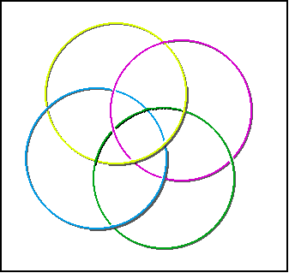

**Questions**

1. Describe and explain ONE advantage and ONE disadvantage that MNCs bring to NICs (4)

Advantage ______________________________________________________________________________________________________________________________________________________________________________________________

Explanation___________________________________________________________________________________________________________________________________________________________________________________________________________________________________________________________________________________

Disadvantage___________________________________________________________________________________________________________________________________________________________________________________

Explanation _____________________________________________________________________________________________________________________________________________________________________________________________________________________________________________________________________________________________

**Resource 4 – MARS UNILEVER AND COCA COLA**



**TASK 1** - In the clouds note four key ways that these MNCs look after their workers.

**Questions** **1.** Using named examples, suggest and explain 3 ways in which MNCs look after their workers.

Way ___________________________________________________________________________________________

Explanation ____________________________________________________________________________________ ______________________________________________________________________________________________________________________________________________________________________________________________

Way ___________________________________________________________________________________________

Explanation___________________________________________________________________________________________________________________________________________________________________________________________________________________________________________________________________________________

Way ___________________________________________________________________________________________

Explanation___________________________________________________________________________________________________________________________________________________________________________________________________________________________________________________________________________________

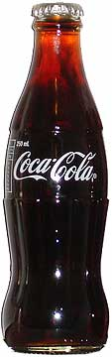

**TASK 2** – Using resource 6 add in the problems that Coke are accused of bringing to India into the “pour”.

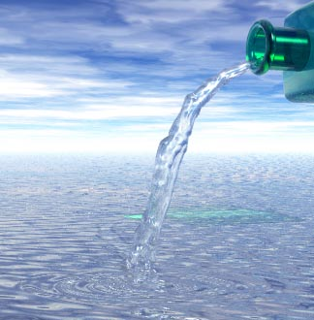

**Task 3 -** Using the bottom of resource 4, (and resources 4,5 and 6) and your own learning, add in the advantages for MNCs of opening premises in NICS and then the advantages for NICs of allowing MNCs to locate there onto the hands below. You can use the fingers**!**

**Advantages for MNCs**

**Advantages for NICs**

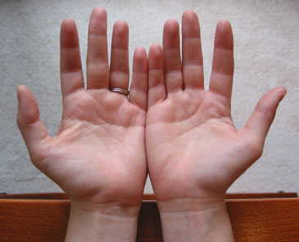

**Question 2** - Choose one of the following roles

* CEO (the big boss!)of an MNC

Or

* the Prime Minister of an NIC

In that role, describe and explain 1 major advantage and 1 major disadvantage for MNCs in NICs. **(8)**

Advantage____________________________________________________________________________________________________________________________________________________________________________________

Explanation__________________________________________________________________________________________________________________________________________________________________________________________________________________________________________________________________________________________________________________________________________________________________________________________________________________________________________________________________________

Disdvantage____________________________________________________________________________________________________________________________________________________________________________________

Explanation_______________________________________________________________________________________________________________________________________________________________________________________________________________________________________________________________________________________________________________________________________________________________________________________________________________________________________________________________________________________________________________________________________________________

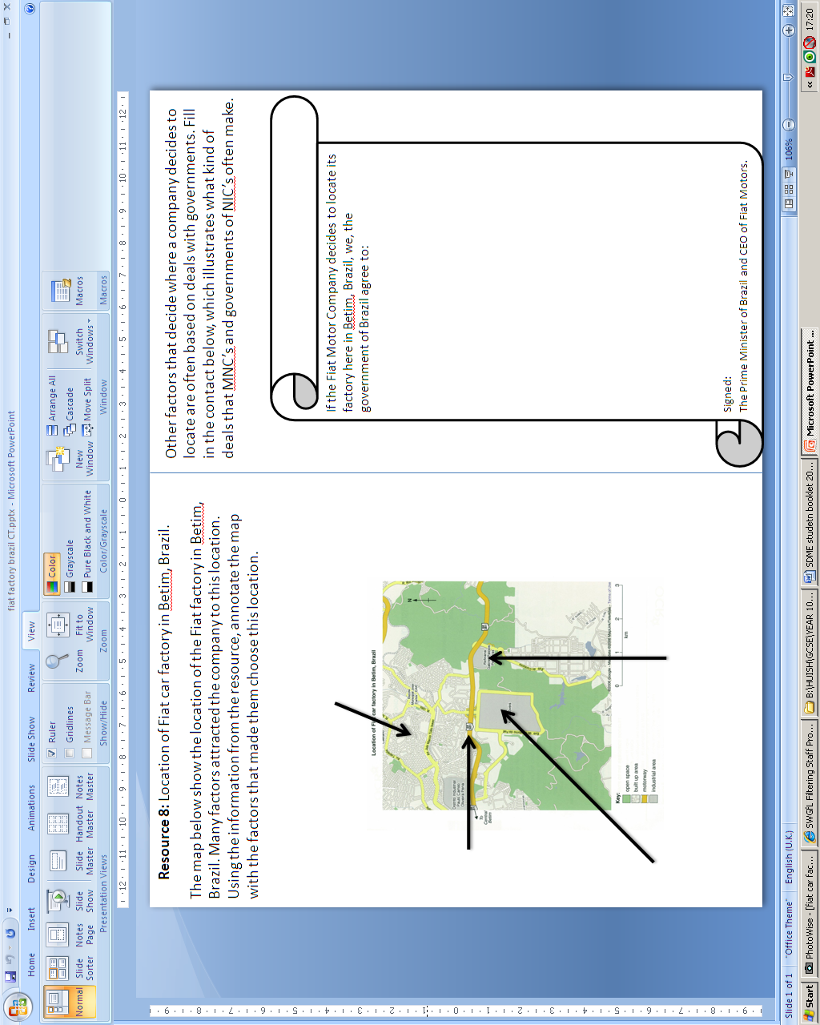

**The Decision**

As an MNC, Fiat has many options as to where it locates. As the car industry hits uncertain times, many factories around the world are closing or moving to locations which can offer it cheaper deals and more benefits then NIC’s.

Fiat has been presented with the following options about the future of its manufacturing plant in Brazil:

1. **Close the plant and move to another country.**
2. **Stay in Brazil and keep the plant open**
3. **Allow the factory to be run by the Brazilian Government.**

Each of these options have advantages and disadvantages and it is up to you to choose the option that you think is most suitable.

For the option you choose you must give **two detailed reasons** **for your choice**, **give a reason why you did not chose each of the others** and finally **explain why some people may not agree** with your choice.

**Option 1: Close the plant**

Advantage 1:

Advantage 2:

Disadvantage 1:

Disadvantage 2:



**Option 2: Keep the plant open**

Advantage 1:

Advantage 2:

Disadvantage 1:

Disadvantage 2:

**Option 3: Give the plant to the Brazilian Government**

Advantage 1:

Advantage 2:

Disadvantage 1:

Disadvantage 2:

**BIG Question – (16 Marks)**

You do not have to use this structure, please use paper if you need to.

For the option you choose you must give **two detailed reasons** **for your choice**, **give a reason why you did not chose each of the others** and finally **explain why some people may not agree** with your choice.

Option Chosen __________________________________________________________________________

Reason 1 ____________________________________________________________________________________________________________________________________________________________________________________________________________________________________________________________________________________________________________________________________________________________Reason 2 ____________________________________________________________________________________________________________________________________________________________________________________________________________________________________________________________________________________________________________________________________________________________

Rejection of 1st Option __________________________________________________________________________________________________________________________________________________________________________________________________________________________________________________________________________________________________________________________________________________________________________________________________________________________________________________________________________________________________________________________________________

Rejection of 2nd Option __________________________________________________________________________________________________________________________________________________________________________________________________________________________________________________________________________________________________________________________________________________________________________________________________________________________________________________________________________________________________________________________________________

Why some people may not agree ____________________________________________________________________________________________________________________________________________________________________________________________________________________________________________________________________________________________________________________________________________________________ __________________________________________________________________________________________________________________________________________________________________________________________________________________________________________________________________________________________________________________________________________________________________________________________________________________________________________________________________________________________________________________________________________