Sadiq Khan's £10 pollution 'T-charge' for older cars added to London's congestion charge
Highly polluting vehicles, broadly registered before 2005, will be hit with the extra £10 charge
- NICHOLAS CECIL
- Tuesday 5 July 2016
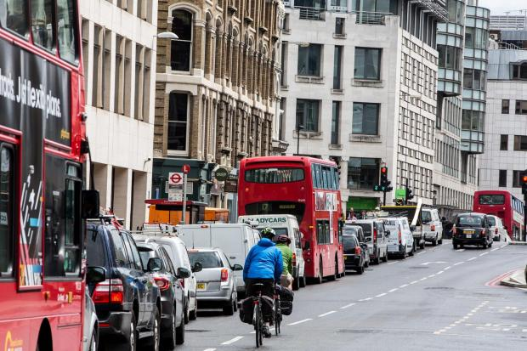
The new T-charge will apply to ALL diesel and petrol vehicles Alex Lentati
Motorists driving vehicles belching out filthy fumes are set to be hit with a £10 “T-charge” to enter central London from next year.
The new toxicity levy was part of a radical package of measures billed by mayor Sadiq Khan as the toughest crackdown on the most polluting vehicles by any major city in the world.
The T-charge would apply to all vehicles, diesel and petrol, with pre-Euro 4 emission standards, broadly those registered before 2005.It would be imposed on top of the £11.50 congestion charge.
On the 60th anniversary of the Clean Air Act, introduced to tackle smogs blighting London, Mr Khan said: “Just as in the 1950s, air pollution in London today is literally killing Londoners.
“But unlike the smoky pollution of the past, today’s pollution is a hidden killer.
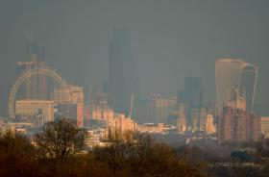
READ MORE

'Pollution signs should be put up in London's blackspots', says Sadiq

“Urgent action is now needed to ensure Londoners no longer have to fear the very air we breathe.”
Other proposals put out for consultation today include:
- Introducing the central London Ultra Low Emission Zone one year earlier in 2019. Cars, vans and motorbikes not meeting set emission standards would have to pay £12.50 a day, and lorries, coaches and buses £100.
- Extending the ULEZ from 2020 from the congestion charge area to the North and South Circulars for motorcycles, cars and vans - and London-wide for lorries, buses and coaches.
- Bringing forward the requirement for all double–deck buses to be ULEZ-compliant in central London from 2020 to 2019.
- Creating clean bus corridors to tackle the worst pollution hotspots by putting cleaner buses on the dirtiest routes.
- Drawing up a detailed proposal for a national diesel scrappage scheme, which will pile pressure on ministers to adopt it despite being reluctant to do so.
Scientists estimate the annual death toll from toxic air in London to be up to 9,400 and the “public health emergency” has been highlighted by the Evening Standard’s Clean London campaign.
More than 440 schools are in areas where nitrogen dioxide levels are in breach of EU legal limits, according to 2013 data.
Mr Khan, who himself suffers from adult-onset asthma, unveiled his anti-pollution blueprint at Great Ormond Street Hospital where he met Dr Colin Wallis, a consultant in respiratory paediatrics who told him how many young patients live with respiratory conditions exacerbated by poor air quality conditions.
- Farringdon Street in the City is the worst place for toxic pollution in London
- Toxic diesel fumes 'cause people to develop liver spots on their faces'
- 'Alarming' study links traffic fumes to early skin ageing
The hospital’s chief executive Dr Peter Steer said: “Children living in highly polluted areas are four times more likely to have reduced lung function in adulthood, yet improving air quality has been shown to halt and reverse this effect.”
Mike Hawes, chief executive of the Society of Motor Manufacturers and Traders, stressed vehicle manufacturers recognised the air quality “challenge” and were investing billions to engineer the cleanest vehicles in history, from advanced petrols and diesels to plug-in hybrid, pure electric and even hydrogen cars.
“The Euro 6 diesels on sale now are light years away from their older counterparts, with almost zero particulates and drastically reduced NOx allowing them to enter the 2020 London ULEZ without charge,” he added.
Business chiefs also backed Mr Khan for making dealing with filthy air a priority
Jace Tyrrell, chief executive of New West End Company representing West End businesses, said: “We are fully supportive of the Mayor’s consultation, and look forward to working with him and the businesses we represent to deliver a sustainable solution for improving air quality in the West End.”
Kay Boycott, chief executive of Asthma UK, emphasised that latest figures showed toxic air affects nearly 600,000 people living in London with asthma.
Professor John Middleton, president of the Faculty of Public Health, said evidence pointed to the poorest communities being disproportionately exposed and vulnerable to air pollution.
Dr Penny Woods, chief executive of the British Lung Foundation, added: “It’s a tragedy that on the 60th anniversary of the Clean Air Act, we continue to see pollution limits broken in many parts of the capital, urgent action is needed.”
Mr Khan also urged the Government to keep the existing legal limits for air pollutants, agreed at EU level, after Brexit.

