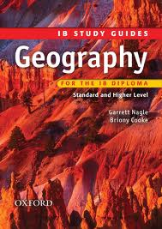

**IB Geography**

**International School of Toulouse**

**Mock Examination – January 2017**

Paper 1 – 1 hour 30 mins (SL/HL)

Paper 2 – 1 hour 20 mins (SL)

2 hours (HL)

Paper 3 – 1 hr (HL)

**Student Revision Pack**

Name : _________________________

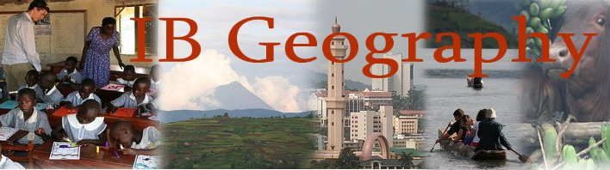

**Paper 1 – HL/SL Students**

**Core Themes – Patterns and Change**

All students sit paper one and there is no difference in the number and difficulty of questions to be answered. Use the IB study guide, your case study sheets and your **UP TO DATE** folders to guide you through the revision process. Using the IB revision guide contents page, you can see that we have completed the following sections:

1. Populations in Transition p.6-21
2. Disparities in Wealth & Development p.22-31
3. Patterns in Environmental Quality & Sustainability p.32-39
4. Patterns in Resource Consumption p.40-49

This paper will take **1hr30** to complete and there will be section A and B to complete.

You need to focus your revision on the 4 key areas outlined above. However, ensure you focus on the following:

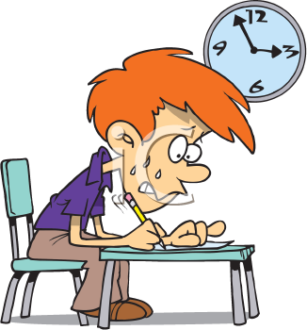

1. **Populations In Transition (15 mins)**

There will be a structured question section which asks you to respond to a graph/chart/photo, then tests your knowledge further

* Understand crude birth rates, crude death rates, birth ratio, natural increase, mortality rate, fertility rate, life expectancy, population momentum / population projection (look at annotated global patterns graphs)
* Reasons that fertility can be extremely high in some countries and what makes it low in others.
* Reasons and an understanding of what causes death rates to fall in MEDC’s and LEDC’s.
* Understand the causes and effects of forced migrations and positive / negative effects on country or origin / destination.

1. **Disparities in Wealth and Development (15 mins)**

There will be a structured question section which asks you to respond to a graph/chart/photo, then tests your knowledge further

* What is the HDI & GNI and what are its strengths and weaknesses?
* How can global disparities be reduced? Focus on Trade and Aid. (see sample essay on the revision page of the website) Group work case studies. Live Aid, Live 8, Remittances to Africa, Make Poverty History etc.
* Can the above schemes actually make the situation worse and increase those disparities?

1. **Patterns in Environmental Quality & Sustainability (15 mins )**

There will be a structured question section which asks you to respond to a graph/chart/photo, then tests your knowledge further

* Recognise the importance/values of soil and can explain the causes and consequences of soil degradation.
* Explain how soil degradation can be minimised by one scheme.
* Be able to explain the importance of freshwater (note HL cross over) and challenges posed by economic and physical water scarcity in vulnerable communities.

1. **Patterns in Resource Consumption**

There will be a structured question which asks you to respond to a graph/chart/photo, then tests your knowledge further

* Recognise global patterns in oil discovery and consumption and be able to identify patterns & trends on a graph.
* Remember how the Hubbard’s Peak works and what it aims to show.
* Remember the last significant discoveries of oil and where new supplies may be and link to possible environmental issues concerned with extraction.

**In section B**, you will see question 5, 6 & 7. Each of these are 15 mark questions and you need to **CHOOSE 1 ONLY to complete. – 30 mins.**

**Paper 2 (SL/ 1hr20 mins) (H/L 2hrs)**

1. **Sport, Leisure & Tourism (HL & SL Students) 1 hr 20 minutes**

**CHOOSE QUESTION 9 & 10 (40 mins each question)**

* Definitions of sport, leisure and tourism.
* What have global levels of sport, leisure & tourism grown in recent years?
* Be able to define and give reasons for growth of tourism in more ‘remote locations’ and the activities that tourists now do when they are there.
* Understand the difference between ecotourism and sustainable tourism and be able to write at length about sustainable tourism management in different environments (Sitges & Machu Picchu)
* Understand what heritage tourism means and give examples.
* Revise the Ligue 1 case study – location of team and residence of supporters (Toulouse FC & Marseille/PSG).

**SL Students will finish their examination at this point.**

1. **Freshwater (HL) additional 40 minutes**

**CHOOSE QUESTION 2**

* Understand how the hydrological cycle and its different features. Make sure you know the main processes and definitions Inc. infiltration, throughflow, base flow etc and positive and negative feedback.
* Explain the functioning of a hydrograph and be able to describe how hydrographs are responsive to human and physical factors.
* Explain the importance of ice caps to the global supply of freshwater and consequences of an increase / decrease in ice on people.
* Recognise a range of river features in the upper, middle and lower course of a river.
* Revise your flooding in Pakistan case study and summary sheets. Focus on the human & physical nature of the flood event

**Paper 3 HL – 1 Hour (choose one of the three combinations of 10 & 15 marks question)**

* How can globalization be measured?
* The global core, semi periphery and periphery
* Effects of different transboundary pollution and movement of e-waste.
* The main factors for and issues caused by the global spread of consumer culture. McDo & Coca Cola.
* Study your loss of sovereignty case study and the impacts of global interactions on national governments.
* The impacts and reasons for outsourcing on core, semi periphery countries. Apple
* The impacts of international migration on local cultures (note paper 1 crossover). France & English case study

Planning ahead …

….

**H/L & S/L Paper 1 - Exam Date – 3rd January 2017**

**H/L & SL Paper 2 – Exam Date – 5th January 2017**

**HL & S/L Paper 3 – Exam Date - 11th January 2017**

If you need any help with revision or need to contact Mr Podbury you can on the following address: [podbury_m@intst.net](mailto:podbury_m@intst.net)

Checklist before leaving school: I have got,

Folder

Work Book

Case Study Booklet

IB revision guide

Copies of texts needed

