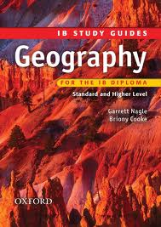

**IB Geography**

**International School of Toulouse**

**Mock Examination – January 2016**

Paper 1 – 1 hour 30 minutes (SL/HL)

Paper 2 – 40 mins (SL) 1 hr 20 (HL)

Paper 3 – 1 hr (HL)

**Student Revision Pack**

Name : _________________________

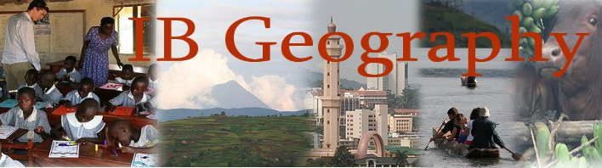

**Paper 1 – HL/SL Students**

**Core Themes – Patterns and Change**

All students sit paper one and there is no difference in the number and difficulty of questions to be answered. Use the IB study guide, your case study sheets and your **UP TO DATE** folders to guide you through the revision process. Using the IB revision guide contents page, you can see that we have completed the following sections:

1. Populations in Transition p.6-21
2. Disparities in Wealth & Development p.22-31
3. Patterns in Environmental Quality & Sustainability p.32-39

***(Real exam will have a fourth section - Patterns in Resource Consumption p.40-49) **Not in this exam\*\****

This paper will take **1hr30** to complete and there will be section A and B to complete.

You need to focus your revision on the 3 key areas outlined above. However, ensure you focus on the following:



1. **Populations In Transition (15 mins)**

There will be a structured question section which asks you to respond to a graph/chart/photo, then tests your knowledge further

* Understand crude birth rates, crude death rates, birth ratio, natural increase, mortality rate, fertility rate, life expectancy, population momentum (look at annotated global patterns graphs)
* Reasons that fertility can be extremely high in some countries and what makes it low in others.
* Reasons and an understanding of what causes death rates to fall in MEDC’s and LEDC’s.
* Understand the causes and effects of internal migrations (China) in terms of reducing disparities within countries.

1. **Disparities in Wealth and Development (15 mins)**

There will be a structured question section which asks you to respond to a graph/chart/photo, then tests your knowledge further

* What is the HDI & GNI and how is it calculated?
* Distinguish between formal and informal employment.
* How can global disparities be reduced? Focus on Debt Relief and Remittances. (see sample essay on the revision page of the website) Group work case studies. Live Aid, Live 8, Remittances to Africa, Make Poverty History etc.
* Can some of the above schemes actually make the situation worse and increase those disparities.

**For the above two points, you will need your joint project booklets on Zimbabwe and Reducing Disparities.

1. **Patterns in Environmental Quality & Sustainability (15 mins )**

There will be a structured question section which asks you to respond to a graph/chart/photo, then tests your knowledge further

* The difference between physical and economic water scarcity and case study examples of places experiencing water shortages.
* Recognise the importance of soil and can explain the consequences of soil degradation and its causes.
* Explain how soil degradation can be minimised by one scheme.
* Be able to explain the importance of biodiversity in the tropical rainforest.
* Be able to write in some detail about the atmospheric energy budget and internal and external forcing’s and their effects on the greenhouse and advanced greenhouse effect.

**Paper 2 (SL/ 40 mins) (H/L 1hr 20 mins)**

1. **Sport, Leisure & Tourism (HL & SL Students) 40 minutes**

**CHOOSE QUESTION 1 or 2**

* Definitions of sport, leisure and tourism.
* Revise your reasons for growth of tourism in more remote locations and the activities that tourists now do when they are there.
* Understand the difference between ecotourism and sustainable tourism.
* Revise your ecotourism case study – what are the pros and cons of such a scheme and be able to evaluate its overall success.
* Be able to evaluate how sporting events can promote urban regeneration.
* **One of the SLT questions contains a map with some activities based on knowing 4 figure grid references, grid lines, contour lines and using the key and other data to interpret landscapes**

**SL Students will finish their examination at this point.**

1. **Freshwater (HL) 40 minutes**

**CHOOSE QUESTION 9 or 10**

* Understand how the hydrological cycle and its different features. Make sure you know the main processes and definitions Inc. infiltration, throughflow, base flow etc and positive and negative feedback.
* Explain the functioning of a hydrograph and be able to describe how hydrographs are responsive to human and physical factors.
* Explain the importance of ice caps to the global supply of freshwater and consequences of an increase / decrease in ice.
* Recognise a range of river features in the upper, middle and lower course of a river.
* Revise your wetlands case study and be confident with the pros and cons of the management strategy under focus.

**Paper 3 HL – 1 Hour**

* How can globalization be measured?
* Effects of different types of transport on the reduction of friction of distance and ‘The Shrinking World’.
* The main drawbacks of a rapid onset of a variety of global interactions, e.g. environmental, cultural dilution, homogenization of landscapes etc.
* Also, be aware of all the positive factors that global interactions brings to populations and societies globally, e.g. cultural awareness, technology, transportation, goods & services, financial flows, sharing ideas etc.
* Internet and mobile phone development in core and periphery case study.

Planning ahead …….

H/L & S/L Paper 1 - Exam Date – **J**anuary 2016

H/L & SL Paper 2 – Exam Date –  January 2016

HL & S/L Paper 3 – Exam Date -  **January** 2016

If you need any help with revision or need to contact Mr Podbury you can on the following address: [podbury_m@intst.net](mailto:podbury_m@intst.net)

Best of all, get in contact with me using the Facebook group page:

Checklist before leaving school: I have got,

Folder

Work Book

Case Study Booklet

IB revision guide

Copies of texts needed

