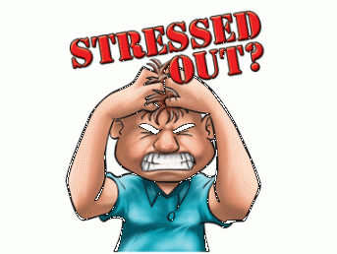 **Y7 Geography.@.IST**

**Pin me to the wall at home.**

**Revision List for the Geography Exam**

***“Don’t stress – Be cool, smart and prepared”***

**So, what is all this revision about then?** You are going to be required to look over your notes from the last few months and prepare for a 1 hour examination to be completed in the hall.

You will be tested on three important learning areas:

* **Knowledge** – Knowing where places are. Being able to locate places on a map. Remembering key facts and figures. Knowing where things happen **e.g. locations of plate boundaries and tornado alley.**
* **Skills** – Being able to plot data and being able to read maps. Being able to calculate and manipulate geographical data so that you can analyse it, **e.g. recognising contour intervals and relating to height and shape of the land.**
* **Understanding** – Why things happen? Making connections between the human and physical environments. Taking into account the views of different people and making decisions **e.g. how do people try to minimise the impacts of natural hazards on their lives.**

**The stuff that you will need to know.**

1. What is a natural hazard?
2. What is a tornado and how does one form?
3. Can you name of location in the USA of the major areas of Tornado action?
4. Can you explain how tornadoes are measured?
5. Can you name each of the layers of planet earth from the inside out?
6. Can you describe the layer that we live on?
7. Can you locate and name the major plate boundaries?
8. Can you explain each of the four types of plate boundary?
9. Can you explain how a volcano is formed and can you label its main features?
10. Where and why do earthquakes occur?
11. What is the difference between the focus and epicentre?
12. Do you know about an earthquake that happened somewhere in the world?
13. How can earthquakes be measured?
14. Can you do 4 and 6 figure grid references?
15. Can you measure scale on map?
16. Can you tell what the shape of the land is like?
17. Can you remember how is height measured on a map?

**That’s all folks. Revise hard and good luck. If you need any help, come and see me. I can often be found hiding from you in S02!**

**Remember, all our work in on** [**www.geographypods.com**](http://www.geographypods.com) **and you can use the forum too……**